

HR133/HR160 SATCOM System

User and Troubleshooting Guide

# [A] Revision History

Changes to this document are controlled by paragraph rather than by sheet to facilitate word processing and change control. The revision level for this document is the latest revision number of any paragraph, figure, or table. Each paragraph, figure, or table has its revision letter enclosed in brackets between its number and its title or caption. The table of contents following the title sheet shall serve as the revision index for all paragraphs, figures, and tables within this document. This index identifies the portion of the document affected by the latest change. The revision chronology for changes to this document is listed as follows.

Revision History Table

| Revision | Date | By | ECO | Description |
| --- | --- | --- | --- | --- |
| A | 11/13/15 | A. Laflamme | 1538 | Initial release |
| B | TBD | A. Laflamme/ B. Kelley |  | Added information about ESM functionality.  Revise Software loading procedures, added Troubleshooting section |

**[A] Proprietary Information**

This manual contains proprietary information that belongs to Astronics AeroSat Corporation and is intended for use during the installation and maintenance of the AeroSat SATCOM System. The information in this manual may not be used, reproduced, or disclosed to any other party for any other purpose without the expressed written consent of Astronics AeroSat Corporation.

**[A] Technical Support**

The AeroSat SATCOM System is manufactured and supported by:

**Astronics AeroSat Corporation**

62 Route 101A

Amherst, NH 03031

Main Office phone: +1 603 879 0205

Emergency Support Number: +1 603 400 2528

©2016 Astronics AeroSat Corporation. All rights reserved.

**Table of Contents**

[[A] Revision History ii](#_Toc442905207)

[1 [A] Introduction 1-1](#_Toc442905208)

[1.1 [B] Purpose 1-1](#_Toc442905209)

[1.2 [B] Scope 1-1](#_Toc442905213)

[1.3 [B] Audience 1-1](#_Toc442905220)

[1.4 [B] Reference Documentation 1-1](#_Toc442905221)

[1.5 Third-Party Reference Documentation 1-1](#_Toc442905224)

[1.6 [B] Symbols and Style Conventions 1-2](#_Toc442905225)

[1.7 [A] Acronym and Term Definitions 1-2](#_Toc442905226)

[2 [B] KU-Band System Overview 2-4](#_Toc442905227)

[3 [B] SATCOM System Line Replaceable Units 3-1](#_Toc442905228)

[3.1 [B] Gimbaled Antenna Unit (GAU) 10950 3-1](#_Toc442905229)

[3.2 [B] Antenna Control with Modem Unit (ACMU) 10951 3-1](#_Toc442905230)

[3.3 [B] High Power Transceiver (HPT) 10951 3-2](#_Toc442905232)

[3.4 [B] Static Inverter 15997 — HR133 Installations Only 3-2](#_Toc442905234)

[3.5 [B] Inertial Navigation System —](#_Toc442905235) *[HR160 Configurations Only](#_Toc442905235)* [3-2](#_Toc442905235)

[3.6 Line Replaceable Interior Cables 3-2](#_Toc442905243)

[3.7 [B] Radome and Radome Attachment Ring 3-3](#_Toc442905244)

[4 [B] Functional Checkout Procedures 4-1](#_Toc442905245)

[4.1 [B] Functional Checkout Procedure Prerequisites 4-2](#_Toc442905246)

[4.2 [A] Power-On and Connectivity 4-3](#_Toc442905247)

[4.2.1 [A] System Power Verification 4-3](#_Toc442905248)

[4.3 [A] Initial Configuration Verification 4-4](#_Toc442905249)

[4.4 [A] Navigation Subsystem Verification 4-6](#_Toc442905250)

[4.5 [B] Visually Verify System Functionality 4-8](#_Toc442905251)

[4.6 [A] Verify System Functionality from the Web Interface 4-8](#_Toc442905252)

[4.6.1 [B] Ping the ACMU to Verify Connectivity 4-12](#_Toc442905253)

[4.7 [A] System Alignment 4-13](#_Toc442905254)

[4.7.1 [A] Perform a Manual System Alignment 4-13](#_Toc442905255)

[5 [A] Line Replaceable Unit Provisioning 5-1](#_Toc442905256)

[5.1 [B] Initial Provisioning Procedures 5-1](#_Toc442905257)

[5.1.1 [B] LRU Replacement Prerequisite Steps 5-1](#_Toc442905260)

[5.1.2 [B] ACMU Replacement 5-2](#_Toc442905261)

[5.1.3 [B] HPT Replacement 5-3](#_Toc442905262)

[5.1.4 [B] GAU Replacement 5-3](#_Toc442905263)

[6 [B] SATCOM System Software Updates 6-1](#_Toc442905264)

[6.1 [B] ESM Blanking Zones 6-2](#_Toc442905266)

[6.1.1 [B] ESM Blanking Zones Text File 6-2](#_Toc442905268)

[6.1.2 [B] Uploading an EMS Blanking Zones File 6-3](#_Toc442905269)

[6.2 [B] SATCOM System Software Package 6-7](#_Toc442905271)

[6.3 [B] Updating the SATCOM System Software 6-7](#_Toc442905272)

[6.4 [B] SATCOM System Configuration Files 6-12](#_Toc442905273)

[6.4.1 [B] Uploading a SATCOM System Configuration File 6-12](#_Toc442905285)

[6.5 [B] Aircraft Specific Configuration Values 6-16](#_Toc442905377)

[7 [B] Troubleshooting the SATCOM System 7-1](#_Toc442905378)

[7.1 SATCOM System Troubleshooting Prerequisites 7-1](#_Toc442905379)

[7.2 [1] Troubleshooting Provisions 7-1](#_Toc442905381)

[7.3 [B] Troubleshooting Site Prerequisites 7-1](#_Toc442905383)

[7.4 [B] Aircraft Power Requirements 7-1](#_Toc442905384)

[7.5 [B] Short Turn-Time for Fault Isolation 7-2](#_Toc442905387)

[7.6 [B] GAU 7-2](#_Toc442905388)

[7.7 [B] ACMU 7-2](#_Toc442905389)

[7.7.1 Fault Ball 7-2](#_Toc442905391)

[7.7.2 Power Indicator 7-2](#_Toc442905392)

[7.7.3 Enable Indicator 7-3](#_Toc442905393)

[7.7.4 LED BIT Code Display 7-3](#_Toc442905394)

[7.7.5 [B] ACMU LED Indicators during Boot Sequence 7-3](#_Toc442905397)

[7.7.6 [B] ACMU LED Display Warning Codes 7-4](#_Toc442905399)

[7.7.7 [B] ACMU Fault Codes for ACMU Replacement 7-4](#_Toc442905400)

[7.7.8 [B] ACMU Fault Codes for External Problems 7-5](#_Toc442905401)

[7.8 HPT 7-6](#_Toc442905403)

[7.9 [B] Time-Available Fault Isolation 7-6](#_Toc442905404)

[7.10 [1] Configuring and Connecting the Laptop to the ACMU 7-6](#_Toc442905405)

[7.10.1 [B] Normal System Status Web Page 7-8](#_Toc442905406)

[7.10.2 [1] Normal System Status with Expanded Details 7-8](#_Toc442905407)

[7.10.3 [B] Faulted Main Web Page 7-9](#_Toc442905408)

[7.10.4 [B] Faulted System Status Web Page 7-10](#_Toc442905409)

[8 [A] ACMU System Check Codes 1](#_Toc442905410)

[8.1 [A] System “Not Installed” State 1](#_Toc442905411)

[8.2 [A] System “Installed” State 3](#_Toc442905412)

[8.3 [A] Web-based System Check Numeric LED Codes 3](#_Toc442905413)

[9 [A] Computer Configuration 1](#_Toc442905414)

[9.1 [A] Objective 1](#_Toc442905415)

[9.2 [A] Configure the Maintenance Computer 1](#_Toc442905416)

List of Figures

[Figure 2.1 — HR133/HR160 Gimballed Antenna Unit (GAU) 2-4](#_Toc442899357)

[Figure 4.1 — ACMU LEDs and Fault Ball Power-up Sequence 4-3](#_Toc442899358)

[Figure 4.2 — ACMU 4-4](#_Toc442899359)

[Figure 4.3 — SATCOM System Home Page 4-5](#_Toc442899360)

[Figure 4.4 — System Product Information Page 4-5](#_Toc442899361)

[Figure 4.5 — SATCOM System Home Page 4-7](#_Toc442899362)

[Figure 4.6 — Example of Navigation Data Display (Total and INTR incrementing) 4-7](#_Toc442899363)

[Figure 4.7 — SATCOM System Home Page 4-9](#_Toc442899364)

[Figure 4.8 — Example of Healthy System Functionality 4-10](#_Toc442899365)

[Figure 4.9 — Example of Unhealthy System Functionality 4-10](#_Toc442899366)

[Figure 4.10 — Example of the System Status Page displaying the Control and Gimbal options. 4-10](#_Toc442899367)

[Figure 4.11 — Link Closed 4-12](#_Toc442899368)

[Figure 4.12 — Run Command Prompt 4-12](#_Toc442899369)

[Figure 4.13 — Example of a Ping Command and ACMU Response 4-13](#_Toc442899370)

[Figure 4.14 — SATCOM System Home Page 4-14](#_Toc442899371)

[Figure 4.15 —Alignment Process Started 4-15](#_Toc442899372)

[Figure 5.1 — System Configuration Page — Not Installed State 5-1](#_Toc442899373)

[Figure 5.3 — GAU Serial # and Part # on the System Product Information Page 5-4](#_Toc442899374)

[Figure 6.1 — SATCOM System Home Page 6-3](#_Toc442899375)

[Figure 6.2 — Utility Functions 6-4](#_Toc442899376)

[Figure 6.3 — Load ESM Blanking Zones 6-4](#_Toc442899377)

[Figure 6.5 — Blanking Map Transfer Status 6-6](#_Toc442899378)

[Figure 6.6 — SATCOM System Home Page 6-8](#_Toc442899380)

[Figure 6.7 — ACMU Control Application Main Menu Bar 6-8](#_Toc442899381)

[Figure 6.8 — Utility Functions 6-9](#_Toc442899382)

[Figure 6.9 — Software Update 6-9](#_Toc442899383)

[Figure 6.10 — Software Update Status 6-11](#_Toc442899384)

[Figure 6.11 — SATCOM System Home Page 6-13](#_Toc442899385)

[Figure 6.12 — System Installation Support Page 6-14](#_Toc442899386)

[Figure 6.13 — System Configuration Page 6-14](#_Toc442899387)

[Figure 6.15 —System Configuration Status page — Process Started 6-15](#_Toc442899388)

[Figure 6.16 — System Configuration Page — All Items Configured Successfully/Task Completed 6-16](#_Toc442899389)

[Figure 6.17 — SATCOM System Home Page 6-17](#_Toc442899391)

[Figure 6.18 — System Installation Support 6-17](#_Toc442899392)

[Figure 6.19 — System Configuration Page 6-18](#_Toc442899393)

[Figure 7.1 — ACMU Indicators 7-2](#_Toc442899394)

[Figure 7.2 — ACMU LED Indicators during Boot Sequence 7-3](#_Toc442899396)

[Figure 7.3 — ACMU Status Indicators 7-4](#_Toc442899397)

[Figure 7.6 — HPT Indicators 7-6](#_Toc442899399)

[Figure 7.7: [B] Typical HR133/HR160 Antenna System Web Site Home Page 7-7](#_Toc442899400)

[Figure 7.8: [IR] Normal System Status Web Page 7-8](#_Toc442899401)

[Figure 7.9: [B] Normal System Status Web Page with Expanded Details 7-9](#_Toc442899402)

[Figure 7.10: [IR] Faulted Main Web Page 7-9](#_Toc442899403)

[Figure 7.11: [IR] Faulted System Status 7-10](#_Toc442899404)

[Figure 7.12: [1] Faulted System Status with Expanded Details 7-10](#_Toc442899405)

[Figure 7.13: [1] Faulted Gimbal Control Web Page 7-11](#_Toc442899406)

[Figure 7.14: [1] Normal Gimbal Control Web Page 7-11](#_Toc442899407)

List of Tables

[Table 1‑3: [B] Acronyms and Abbreviations 1-2](#_Toc442452053)

[Table 4.4 — Visually Verify System Functionality Procedure 4-8](#_Toc442452054)

[Table 4.5 — Verify System Functionality from the Web Interface Procedure 4-8](#_Toc442452055)

[Table 5.1 — LRU Replacement Prerequisites 5-1](#_Toc442452056)

[Table 5.3 — Basic Steps for HPT Replacement 5-3](#_Toc442452057)

[Table 5.4 — Basic Steps for GAU Replacement 5-3](#_Toc442452058)

[Table 6.1 — Software Update Procedure 6-7](#_Toc442452059)

[Table 6.2 — Configuration File Upload Procedure 6-12](#_Toc442452060)

[Table 7‑1: [IR] ACMU Status Indicators 7-3](#_Toc442452061)

[Table 7‑2: [B] ACMU Fault Codes Indicating ACMU Replacement 7-5](#_Toc442452062)

[Table 7‑3: [B] ACMU Fault Codes Indicating External (Cable) Problems 7-5](#_Toc442452063)

# [A] Introduction

## [B] Purpose

The **SATCOM System User and Troubleshooting Guide** contains the procedures on how to perform a provisioning and functional checkout of the HR133 and HR160 SATCOM Systems during an installation, after a software update, and after troubleshooting a failed line replaceable unit (LRU).

This guide also provides step-by-step instructions on how to detect, isolate, and resolve issues that affect the normal operating state of the HR133/HR160 SATCOM System.

## [B] Scope

The procedures in this guide are useful for performing a provisioning and functional checkout of the HR133/HR160 SATCOM Systems. This includes verifying system functionality for the Antenna Control Modem Unit (ACMU), the High Power Transceiver (HPT), and the Gimbaled Antenna Unit (GAU).

## [B] Audience

This guide is exclusively for avionics repair technicians assigned to service installed and commissioned SATCOM systems that may have a line replaceable unit failure.

## [B] Reference Documentation

Table .1 — Reference Documentation

|  |  |
| --- | --- |
| Document Number | Document Title |
| 10951-ICD | ICD, Antenna Control Unit, Integrated Modem Rev B |
| 10951-IDD | Antenna Control Modem Unit Interface Description Document |
| 10952-ICD | ICD, High Power Transceiver |
| 10950-ICD | ICD, Gimbal Antenna Unit, HR133 |
| 15997-ICD | ICD, Inverter, Static 1KVA |
| 19857 | HR133 Wiring Diagram |
| 000-133-IP | Dornier 228 Installation Procedure, HR133 SATCOM System |
| 000-160-IP TBD | Ilyushin IL-38 Installation Procedure, HR160 SATCOM System |
| Third-Party Reference Documentation Table 1.2 — Third-Party Reference Documentation | |
| Document Number | Document Title |
| C-AZ01-13851-001 | Composite Inspection and Structural Repair Methods |
| AC43.13-1B | Acceptable Methods, Techniques and Practices – Aircraft Inspection and Repair.\ |

## [B] Symbols and Style Conventions

The following symbols and style conventions are used to emphasize specific information in this document.

**Table 1.1 — [B] Document Conventions**

|  |  |
| --- | --- |
| Convention | Description |
| **NOTE:** | Identifies additional information or comments that may be useful to the user. |
|  | The **Caution** symbol indicates conditions or practices that could cause damage to equipment or property, for information that is crucial to preventing loss of data or damage to hardware or software, and actions that could result in catastrophic equipment failure. |
|  | The **Warning** symbol indicates conditions or practices that could cause personal injury or death. |
|  | The **Danger** symbol indicates conditions or practices that will cause personal injury or death. |
| Bold | **Bold** typeface identifies commands, buttons, user interface elements, and provides emphasis to text. |

## [A] Acronym and Term Definitions

**Table 1.1.2 — [B] Acronyms and Abbreviations** defines the acronyms abbreviations used in this document.

**Table 1.1.2 — [B] Acronyms and Abbreviations**

| Term | Definition |
| --- | --- |
| ACMU | Antenna Control Modem Unit |
| ARINC | Aeronautical Radio, Incorporated |
| AZ | Azimuth |
| BIT | Built-in Test |
| EL | Elevation |
| GAU | Gimbal Antenna Unit |
| GHz | Gigahertz |
| GUI | Graphical User Interface |
| HPT | High Power Transceiver |
| Hz | Hertz |
| ICD | Interface Control Drawing |
| IF | Intermediate Frequency |
| INS | Inertial Navigation System |
| IP | Internet Protocol |
| LAT | Latitude |
| LED | Light Emitting Diode |
| LO | Local Oscillator |
| LON | Longitude |
| LRU | Line Replaceable Unit |
| MHz | Megahertz |
| NAV | Navigation |
| OVP | Operational Verification procedure |
| POL | Polarization |
| RF | Radio Frequency |
| RX | Receive |
| SATCOM | Satellite Communications |
| SNMP | Simple Network Management Protocol |
| SRM | Structural Repair Manual |
| SW | Software |
| TX | Transmit |
| VAC | Voltage Alternating Current |

# [B] KU-Band System Overview

The Ku-Band SATCOM System consists of control cables, RF and IF Coaxial cables, power cables, bulkhead adapters, and a waveguide. It is provided with 115VAC 360-800 Hz Aircraft Power and the ARINC 429 navigation system data labels. The Inertial Navigation System is separately powered by aircraft 28VDC.

The following diagram shows a simplified Ku-Band SATCOM System that is under test.

Figure 2.1 — HR133/HR160 Gimballed Antenna Unit (GAU)

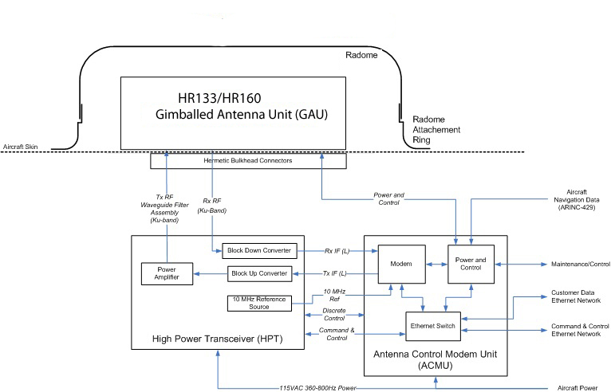

# [B] SATCOM System Line Replaceable Units

A line replaceable unit is a type of hardware component that can be easily removed and installed from its mounting points. When troubleshooting the SATCOM System, fault isolation and field repair is limited to the removal and replacement of failed LRUs. A failure or problem can be isolated to a particular LRU, which can be replaced quickly.

The SATCOM System is made up of the following line replaceable units:

* Gimbaled Antenna Unit (GAU) 10950
* Antenna Control with Modem Unit (ACMU) 10951
* High Power Transceiver (HPT) 10951
* Static Inverter 15997 –*HR133 Installations Only*
* Inertial Navigation System – *HR160 Configurations Only*
* Interior Cables

## [B] Gimbaled Antenna Unit (GAU) 10950

The GAU contains the antenna, associated motors and electronics required to point the antenna toward the desired satellite to receive the satellite signal. The GAU has three axes of motion: Azimuth, Elevation, and Polarization. The Azimuth and Elevation axes provide the main pointing of the antenna at the satellite of interest, while the Polarization axes provides electrical alignment with the polarization angle offset of the satellite. The GAU is mounted external to the aircraft under the radome making it difficult to inspect. Fault isolation is done via the ACMU. The ACMU provides all power, command, and control to the GAU. The GAU contains minimal electronics to maximize reliability. In order to replace a GAU, the radome must be removed first. The radome must be resealed and cured after replacing the GAU. This can take several hours.

For provisioning instructions on how to remove and replace the GAU, see **5.1.4[B] GAU Replacement**

## [B] Antenna Control with Modem Unit (ACMU) 10951

The ACMU provides all command, control, and monitoring of the HR133/HR160 system, including pointing of the GAU antenna. The ACMU receives aircraft position (latitude and longitude) and orientation (pitch, roll, and heading) from the aircraft’s Inertial Navigation System (INS). It calculates the correct pointing angles, and drives the motors on the antenna to the correct location. The ACMU also contains the modem to convert the IF signals exchanged with the HPT to Ethernet, for provision to the aircraft.

The ACMU is mounted within the aircraft overhead and is retained with 4 screw/washer/lock-washer sets. This facilitates easy and rapid removal and replacement should a fault be isolated to this LRU. The ACMU provides the primary interface for fault isolation through a commercial Ethernet cable and the use of the Mozilla Firefox, Google Chrome or Safari web browser. Internet Explorer is not supported.

The ACMU also displays external fault and status indicators to help monitor operation and isolate faults.

For provisioning instructions on how to remove and replace the ACMU, see **5.1.2[B] ACMU Replacement.**

## [B] High Power Transceiver (HPT) 10951

The HPT provides the down and up conversions of the RF signal to/from the Modem IF frequencies. The receive path includes two selectable down conversion Local Oscillator (LO) frequencies:

* 9.75 GHz for the 10.7 to 11.7 band
* 10.75 GHz for the 11.7 to 12.75 GHz band.

This results in an output of 950-1950 MHz and 950 to 2000 MHz respectively to the modem within the ACMU. The transmit path contains a single up-conversion LO at 12.8 GHz, converting the 950-1700 MHz signal from the modem to 13.75-14.5 GHz for the antenna. Once the signal is up-converted, the HPT provides power amplification at RF frequencies for transmission from the GAU antenna.

The HPT includes a fail-safe cable connection to the ACMU. If the connection to J3 is disconnected, the HPT will power down the Power Amplifier and prevent transmissions from the aircraft.

The HPT is mounted within the aircraft and is retained with 4 captive Phillips head fasteners. This facilitates easy and rapid removal and replacement should a fault be isolated to this LRU.

The HPT contains external fault and status indicators to help monitor operation and isolate faults.

For provisioning instructions on how to remove and replace the HPT, see **5.1.3[B] HPT Replacement.**

## [B] Static Inverter 15997 — HR133 Installations Only

The Static Inverter accepts a 28VDC input power and converts it to 115VAC 400 Hz power for the ACMU and the HPT. It is mounted in the aircraft interior overhead, between the ACMU and the HPT.

## [B] Inertial Navigation System — *HR160 Configurations Only*

The Configuration #2 installation receives positional data from the IAI Tammam INS, so the AeroSat/Astronics SATCOM System is not installed in these aircraft. The Configuration #1 Inertial Navigation System consists of an Inertial Reference Unit (IRU) and a GPS antenna with a Coax cable connecting the antenna to the IRU. The IRU is installed on a bracket mounted on the left interior side of the corrugated bulkhead aft of the over-wing access panel. The GPS antenna is installed on the upper skin of the aircraft, within the forward end of the radome ring, on the left side of the aircraft centerline.

## Line Replaceable Interior Cables

The HR133/HR160 SATCOM System has several interior cables that are line replaceable. The specific part numbers are identified by the length of the cable.

* **HPT-to-Bulkhead Penetrations**
  + Waveguide, TX Flex Filter (HPT-J7)
  + Cable, HPT to RX Bulkhead (HPT-J8)
* **HPT-to-ACMU**
  + Cable, TX IF (HPT-J4 to ACMU-J9)
  + Cable, RX IF (HPT-J5 to ACMU-J8)
  + Cable, 10MHZ Ref (HPT-J6 to ACMU-J7)
  + ACMU to HPT Discrete Control Cable (HPT-J3 to ACMU-J3). Includes ARINC-429 inputs to ACMU from aircraft
  + ACMU to HPT Ethernet Control Cable (ACMU-J2C to HPT-J2A)
* **ACMU to Bulkhead**
  + GAU Control /Power Cable (ACMU-J4)
* **LRU Power Inputs**
  + ACMU 115VAC 400Hz Power harness (ACMU-J1)
  + HPT 115VAC 400 Hz Power harness (HPT-J1)
* **Network Data and External Command and Control (ACMU-J2)**
  + ACMU Command and Control Ethernet cable (ACMU-J2A)
  + ACMU Network Data Ethernet Cable (ACMU-J2B)
  + ACMU to HPT Ethernet Control Cable (ACMU-J2C to HPT-J2A)
* **Electrical Bonding straps are attached from each LRU at chassis points specified in the ICDs to the Aircraft Structure**.
* A milliohm meter is required to check for adequate electrical bond to aircraft.
* Resistance must be less than or equal to 2.5 milliohms per attaching surface, or 5 milliohms per bonding wire, or a maximum of 10 milliohms between the airframe and the LRU equipment.

|  |  |
| --- | --- |
|  | An inadequate or missing LRU bond to the aircraft may cause eventual damage to the LRU, requiring replacement of the unit. |

**NOTE: THE GAU ICD HAS NO NOTE TO GROUND THE UNIT**

## 

t

CoaxCoax

# [B] Functional Checkout Procedures

To ensure the HR133/HR160 SATCOM System is operating at peak performance, you must always perform a functional checkout of the system whenever one of the following conditions is met:

* An initial installation of the SATCOM System has just been performed.
* An update to the existing SATCOM System software has just been performed.
* An LRU has been replaced.

The Functional Checkout Procedures in this chapter are broken up into sections, giving you the option of performing only the one(s) that are specific to your particular situation.

* **Section 4.1 Functional Checkout Procedure Prerequisites**
* **Section 4.2 Power-On and Connectivity**
* **Section 4.3 Initial Configuration Verification**
* **Section 4.4 Navigation Subsystem Verification**
* **Section 4.5 Visually Verify System Functionality**
* **Section 4.6 Verify System Functionality from the Web Interface**

## [B] Functional Checkout Procedure Prerequisites

The following prerequisites must be met before performing the **Functional Checkout Procedures**:

* Power is available through one of the following methods:
  + Aircraft main engine power
  + Ground Power Unit (GPU)
  + Hangar power
* The circuit breakers are enabled.
* The power circuit for the SATCOM System is turned on.
* The IRU data source is powered-on and initialized.
* You are connected to the ACMU J5 Maintenance Port via an Ethernet cable.
* There is a clear line-of-site to the satellite to close the link and get on the network.
* The latest version of the Software Update Package is installed on the SATCOM System.
* The latest version of the Base/Production and Customer Configuration Files are installed on the SATCOM System.
* The latest version of the is installed on the SATCOM System.

## [A] Power-On and Connectivity

### [A] System Power Verification

Do the following to verify that the **SATCOM System** is powered on.

Table 4.1 — Verify System Power Procedure

| Step | Action |
| --- | --- |
| 1. | Ensure that the **J1** connector on the ACMU is connected to an appropriate power supply. |
| 2. | Power-on the SATCOM System. |
| 3. | At system start-up, verify that the **Power LED** is red. |
| 4. | Shortly after system start-up, verify that the following conditions are met:   * The **Power LED** turns from red to green. If the **Power LED** remains red for more than 10 minutes, a potential problem could exist. * The **Enable LED** remains off for a minimum of 60 seconds (or longer). * The **Fault Ball** remains dark.   Figure 4.1 — ACMU LEDs and Fault Ball Power-up Sequence |
| 5. | Verify that the **Enable LED** is green.   * If both **Enable** **LED and Power LED** are green, a line-of-site exists to the satellite network, and the ACMU has successfully closed the link. * If a line-of-site does not exist to the satellite network, the **Enable LED** will remain in a yellow state. * Continue to the next step only if the **Power LED** is green and the **Enable LED** is green or yellow. |
| 6. | * Ensure that there are no fault codes in the LED display after the system has completed a boot cycle. * If a fault code is displayed, refer to Appendix A for help identifying the affected sub-system.   Figure 4.2 — ACMU  ACMU_IMG_0416. |

## [A] Initial Configuration Verification

To verify an initial system configuration, do the following:

Table 4.2 — Initial Configuration Verification Procedure

| Step | Action |
| --- | --- |
| 1. | Open a Mozilla Firefox web browser. |
| 2. | Enter the following IP address in the web browser to go to the AeroSat SATCOM home page:  **192.168.64.10**  The SATCOM System Home Page appears.  Figure 4.3 — SATCOM System Home Page |
| 3. | Click **[System Installation]** at the top of the home page.  The **System Installation** page appears.  Figure 4.4 — System Product Information Page |
| 4. | Verify that the following product information is up-to-date:   * The ACMU, GAU, Modem, and HPT serial numbers and part numbers are correct. * The ACMU software and firmware are the latest versions. * The Modem software is the latest version. * The HPT software is the latest version. |
| 5. | If one or more of the software versions are out-of-date, you must install the latest software. See **Chapter 6 — SATCOM System Software Updates** for more information. Otherwise, go to the next step. |
| 6. | Verify that the **Customer Configuration File** and the **Base/Production Configuration File** under the **Configuration** section of the home page are the latest revisions.   * If both of the configuration files are correct, the procedure is complete. * If one or both of the configuration files are incorrect, you must upload the correct configuration file(s). For instructions on how to accomplish this task, see **6.3.3 — Uploading a SATCOM System Configuration File**. |

## [A] Navigation Subsystem Verification

To manually verify that the **Navigation** subsystem is functioning properly, do the following:

Table 4.3 — Navigation Subsystem Verification

| Step | Action |
| --- | --- |
| 1. | Ensure that the aircraft INS is powered-on and stabilized before continuing with this procedure.  If the aircraft INS is not powered on, the system will not point properly and can result in false symptoms and potential failure points. |
| 2. | Open a Mozilla Firefox, Google Chrome or Safari web browser. |
| 3. | Enter the following IP address in the web browser to go to the AeroSat SATCOM home page: **192.168.64.10**  The **SATCOM System Main Page** appears.  **Figure 4.5 — SATCOM System Home Page** |
| 4. | Verify your location and orientation information is correct by referring to the **Location & Orientation** section of the home page. |
| 5. | Ensure that the following fields on the **data stream** line in the **Location & Orientation** section of the home page are streaming data from the Inertial Navigation System.   * **total** — The total number of valid label counts. A valid label is on time and has no data errors. * **invalid** — The number of labels found by the INS to have invalid data. * **INTR** — Indicates labels are being sent by the INS.   The Navigation System is running normally when the **total** and **INTR** values are incrementing but the **invalid** value is not. The system will display the last known location.  Figure 4.6 — Example of Navigation Data Display (Total and INTR incrementing)  http://aerowiki/aerodiags/images/thumb/e/eb/Navigation_Data_Display.JPG/500px-Navigation_Data_Display.JPG |

## [B] Visually Verify System Functionality

You can visually verify system functionality by ensuring that the motor subsystem is calibrated and working properly. In order to view the motor subsystem, the radome must be removed.

Table 4.4 — Visually Verify System Functionality Procedure

| Step | Action |
| --- | --- |
| 1. | Power-on the system. |
| 2. | Verify that the antenna array turns and stops at the forward position, with the array face set to vertical (azimuth = 0, elevation = 0).   * The antenna will pause at the forward position, before moving and pointing to the last known pointing angle. * Depending on the type of antenna installed, you may also be able to view the polarization axis, which will exhibit the same behavior. |

## [A] Verify System Functionality from the Web Interface

Table 4.5 — Verify System Functionality from the Web Interface Procedure

| Step | Action |
| --- | --- |
| 1. | Verify that communication with the ACMU is established by **running the ping command** at the command prompt.  For instructions on how to run the Ping command, see section **4.6.1 — [B] Ping the ACMU to Verify Connectivity.** |
| 2. | Open a Mozilla Firefox, Google Chrome or Safari web browser. |
| 3. | Enter the following IP address in the web browser to go to the AeroSat SATCOM home page: **192.168.64.10**  The **SATCOM System Home Page** appears.  **Figure 4.7 — SATCOM System Home Page** |
| 4. | Click the **[System Status]** link located at the top of the home page to view the status of each component.   * If the system is healthy, the status indicator next to each component will be green and marked **NORMAL**.   Figure 4.8 — Example of Healthy System Functionality     * If the system is unhealthy, the status indicator next to one or more of the components will be either yellow or red, and marked as **WARNING** or **DISABLED**.   Figure 4.9 — Example of Unhealthy System Functionality     * If the **Control** or **Gimbal** has a status of **DISABLED**, **STOPPED,** or **WARNING**, you can view the specific issue with either component, as follows:   + Click **CONTROL** to display a drop-down list of all the Control statuses.   + Click **GIMBAL** to display a drop-down list of all the Gimbal statuses.   Figure 4.10 —System Status for the Gimbal Options and IRU/INS.    **If the GIMBAL has a DISABLED, STOPPED, or WARNING status, click the GIMBAL link to display the status of each axis.**  **The INS status must be green so that it can provide accurate location and orientation data to the rest of the system.** |
| 5. | Verify that there is line-of-site to the satellites in your network before continuing on to the next step. |
| 6. | Do both of the following:   * Go back to the home page by clicking the AeroSat logo in the top, left corner of the page. * Do not continue to the next step until the **Track State** under the **System Status** section displays as **DONE**. |
| 7. | Verify that the following conditions exist under the **System Status** section of the home page, by observing:   * The **Rx Signal Level** is steady, and above 1. * The **Rx Signal Level** data (i.e., Es/No or C/N) is accurate. * The Track State cycling through the following sequence in an attempt to reach a peak signal:   + **SEARCH** — Indicates the system has started up and is searching for a signal. If a signal cannot be acquired, or if the Track State does not start cycling, but remains at **DONE**, reset the Track State by clicking the **CLEAR** button.   + **ACQUIRE** — Indicates the Track State has obtained a signal.   + **COARSE** — A signal is acquired, but not peaked. Tracking adjustments are smaller than those in Acquire   + **FINE** — Close to peak signal, these tracking adjustments are smaller than those in Coarse.   + **SUPERFINE** Checking candidate for peak signal. There are no tracking adjustments.   + **DONE —** Indicates a signal has been found, and the Track Cycle is complete. The **Tracking Offsets** for **AZ** and **EL** are also updated.   **NOTE:** Although Track State may find a signal and reach the **DONE** state in a relatively short period of time, it continues to search for stronger signal, and may periodically cycle to **ACQUIRE**, **COARSE**, **FINE**, or **SUPERFINE**, before eventually going back to **DONE**.   * The satellite pointing angles for **AZ**, **EL**, and **POL** correspond to pointing angles identified for the satellite at **<http://www.satellite-calculations.com/>.** |
| 8. | Verify that the Link is **Closed** under the **SATELLITE** section of the home page.  Figure 4.11 — Link Closed |

### [B] Ping the ACMU to Verify Connectivity

To verify that connectivity with the ACMU is established, run the ping command at the command prompt.

| Step | Action |
| --- | --- |
| 1. | From your desktop, click the **Start Menu**. |
| 2. | From the **Run Command Line**, enter the command: **cmd**.  Figure 4.12 — Run Command Prompt  http://aerowiki/aerodiags/images/thumb/b/bb/Command_Prompt_Window.JPG/300px-Command_Prompt_Window.JPG |
| 3. | Enter following command in the command prompt window. Click **OK**.  **ping 192.168.64.10 -t**  If the ACMU is communicating properly, it will respond to the ping command similar to the example below:  Figure 4.13 — Example of a Ping Command and ACMU Response  [http://aerowiki/aerodiags/images/thumb/4/4b/Ping_command_and_response.JPG/500px-Ping_command_and_response.JPG](http://aerowiki/aerodiags/index.php/File:Ping_command_and_response.JPG) |
| 4. | Return to the procedure requiring the Ping Command. Continue to the next step within that procedure. |

## [A] System Alignment

Once the antenna is mounted to the aircraft, the SATCOM System will automatically align the antenna to the Inertial Navigation System (INS) so that the Roll, Pitch, and Heading alignment offsets are accurately pointing at the satellite. This process may repeat until the differences between successive Heading alignment corrections are minimized.

You can identify the status of the system alignment by viewing the alignment state under the **SYSTEM STATUS** section. If this indicates that the alignment is **Not completed** or **Aborted**, then the alignment either failed at start up or the feature is not configured to run at start up.

### [A] Perform a Manual System Alignment

If the Roll, Pitch and Heading offsets for the antenna and INS do not align during the automatic system alignment process, you must perform a manual system alignment for Roll and Pitch.

Once the Roll and Pitch offset manual system alignment completes, the system will automatically perform an alignment of the Heading. This process may repeat until the differences between successive Heading alignment corrections are minimized.

|  |  |
| --- | --- |
|  | If you cannot detect a signal, or if the pointing angle is incorrect, do not perform this procedure. If you have already started the manual system alignment process, only to discover that a signal does not exist, and/or the pointing angle is incorrect, immediately stop the procedure by clicking the **Abort** button under the **SYSTEM STATUS** section of the home page. |

Table 4.6 — Manual System Alignment Procedure

| Step | Action |
| --- | --- |
| 1. | Open a Mozilla Firefox, Google Chrome or Safari web browser. |
| 2. | Enter the following IP address in the web browser to go to the AeroSat SATCOM home page: **192.168.64.10**  The **SATCOM System Home Page** appears.  Figure 4.14 — SATCOM System Home Page    **During a Manual System Alignment, the Align button toggles into the Abort button.** |
| 3. | Click the **Align** button in the **SYSTEM STATUS** section of the home page to start the manual alignment process.  Figure 4.15 —Alignment Process Started     * The **Align** button will toggle into the **Abort** button as the process starts. * The **Abort** button will toggle back into the **Align** button, and the message **Align: Completed** will display in the lower left corner of the window once the alignment process is complete. * The alignment process is complete when the SATCOM System home page displays **Align: Completed** and the button to the right has changed back to **ALIGN**, with the word **DONE** also displayed to indicate the alignment status. The revised alignment offsets for Roll, Pitch, and Heading are updated on the home page, and are recorded and used to improve/maintain pointing accuracy of the antenna. |

#### Manual System Alignment Failure

If you are unable to complete a manual system alignment, either because it aborted or did not start, it could be due to one or more of the following conditions:

* The **Link** under the **SATELLITE** section of the home page is not **LOCKED** or **CLOSED**.
* The **RX** signal is too low.
* One or more of the subsystems have encountered warnings (for example, **no navigational data** or **tracking has failed**).

# [A] Line Replaceable Unit Provisioning

This chapter contains the initial provisioning procedures for Line Replaceable Units (LRUs). It includes general instructions for replacing the following LRUs:

* ACMU
* GAU
* HPT

Once an LRU is replaced, you can verify that it is functioning properly by running the corresponding functional checkout procedure in **Chapter 4 — Functional Checkout Procedures** to verify that the replacement was successful.

## [B] Initial Provisioning Procedures

Comprehensive testing must be performed immediately following the SATCOM System installation so that system functionality can be properly verified. For step-by-step instructions on how to perform a functional checkout of the SATCOM System, see **Chapter 4 — Functional Checkout Procedures**.

### [B] LRU Replacement Prerequisite Steps

The following prerequisite steps must be performed prior to replacing an LRU.

Table 5.1 — LRU Replacement Prerequisite Steps

| Step | Action |
| --- | --- |
| 1. | Verify that the unit has power. |
| 2. | Verify the unit is in a **Not Installed** state.   * To find out the current installed state, go to the **System Configuration** page by clicking **[System Installation]** at the top of the SATCOM System home page. * If the system is in a different state, you can toggle it to the **Not Installed** state from the System Configuration web page.   Figure 5.1 — System Configuration Page — Not Installed State |
| 3. | Power cycle the system. |
| 4. | View the status bar at the bottom of the home page to verify if the system is running properly:   * The status bar must be green. * The status bar must be **NORMAL** * The time on the status bar time must be incrementing.   Figure 5.2 — System Status on the SATCOM System Home Page |

### [B] ACMU Replacement

General instructions on how to replace the ACMU are as follows:

Table 5.2 — Basic Steps for ACMU Replacement

| Step | Action |
| --- | --- |
| 1. | Power-down the unit. The ACMU is off when the **Power LED** is not lit. |
| 2. | Disconnect all wiring harnesses and Coax cables |
| 3. | Remove the ACMU from its mounting points. |
| 4. | Install the new ACMU onto its mounting points. |
| 5. | Torque the attaching screws to 20 - 25 inch/pounds. |
| 6. | Ensure all the wire harnesses and Coax cables are properly reconnected. Torque the Coax connectors to 8 - 12 inch/pounds. |
| 7. | Perform the Functional Checkout Procedures as described in this manual. |
| 8. | Verify the ACMU Serial Number and Part Number are correctly displayed on the **System Product Informatio**n page. |

### [B] HPT Replacement

General instructions on how to replace the HPT are as follows.

Table 5.3 — Basic Steps for HPT Replacement

|  |  |
| --- | --- |
| Step | Action |
| 1. | Power-down the unit. The HPT is off when the **Power LED** is not lit. |
| 2. | Disconnect all wiring harnesses and Coax cables |
| 3. | Remove the HPT from its mounting points. |
| 4. | Install the new HPT onto its mounting points. |
| 5. | Torque the attaching screws to 20 - 25 inch/pounds. |
| 6. | Ensure all the cables are properly reconnected. Torque the 7/16 inch Coax connectors to 8-12 inch-pounds and the 11/16 inch connector to 12 - 15 inch/pounds. |
| 7. | Perform the Functional Checkout Procedures in this document. |
| 8. | Verify that the HPT serial number and part number are correctly displayed on the **System Product Informatio**n page. |

### [B] GAU Replacement

Table 5.4 — Basic Steps for GAU Replacement

| Step | Action |
| --- | --- |
| 1. | Power-down the unit. The unit is turned off when the Power LED is not lit. |
| 2. | Remove the radome. |
| 3. | Disconnect the following cables:   * Control Harness Connector * Tx and Rx Coax cables |
| 4. | Remove the GAU from the mounting point. |
| 5. | Install the new GAU into the mounting point. |
| 6. | Torque the attaching screws to 20 - 25 inch/pounds. |
| 7. | Do all of the following:   * Connect the Control Harness Connector and the Rx and Tx Coax connectors. * Ensure the Control Harness Connector is fully engaged on the bulkhead feed-through. * Torque the Coax cable connectors to 12 - 15 inch/pounds. |
| 8. | Perform a complete Functional Checkout Procedures, as described in **Chapter 4[B] Functional Checkout Procedures**. |
| 9. | Verify that the GAU serial number and part number are correct on the **System Product Information** page.  Figure 5.3 — GAU Serial # and Part # on the System Product Information Page |
| 10. | Reinstall the radome.  See ***Drawing 19862*** for an illustration on how to install a radome. |

# [B] SATCOM System Updates

To keep the SATCOM System operating at peak performance, you will periodically be required to upload the most recent releases of the following files:

* **SATCOM System Software Package**
* **Base/Production Configuration File**
* **Customer Configuration File**
* **ESM Blanking Zones Text File**







## [B] SATCOM System Software Package

In order to install the SATCOM System software, the required software update package must be accessible on a computer hard drive, thumb drive, or a known network location.

## [B] Updating the SATCOM System Software

Instructions on how to update the SATCOM System software are as follows:

|  |  |
| --- | --- |
| **Caution.jpg** | Power to the aircraft must remain steady during the system software update. Should a break in aircraft power occur while the software is updating, the system may be rendered unusable. |

|  |  |
| --- | --- |
|  | Whenever you update the SATCOM System software, you must also update the Customer Configuration File. Never update the configuration file before updating the SATCOM System software. Otherwise, the SATCOM System may be rendered unusable. |







Table 6.1 — Software Update Procedure

| Step | Action |
| --- | --- |
| 1. | Verify that communication with the ACMU is established by **running the ping command** at the command prompt.  For instructions on how to run the Ping command, see section **4.6.1 — [B] Ping the ACMU to Verify Connectivity.** |
| 2. | Open a Mozilla Firefox, Google Chrome or Safari web browser. |
| 3. | Enter the following IP address in the web browser to go to the SATCOM System Home Page:  **192.168.64.10**  The **SATCOM System Home Page** appears.  Figure 6.6 — SATCOM System Home Page |
| 4. | Click **[Utility Functions]** from the menu bar at the top of the home page.  The **Utility Functions** page appears.  Figure 6.8 — Utility Functions |
| 5. | Click the **Update Software** button from the left side bar panel.  The **Software Update** page appears.  Figure 6.9 — Software Update |
| 6. | Upload the software update file using one of the methods below:   * Click the **Browse** button next to the **localfile** field to navigate to the location on your hard drive containing the software update package (.pkg) file. Click the **Open** button. * *(For Linux and Mac systems only.)* Enter the URL for the location on your hard drive containing the software update (.pkg) in the **-or- URL** field. Enter your username in the **username** field. Enter your password in the **password** field.   **NOTE:** Your operating environment determines the transfer file method that your system will use to upload the files. For example, if you are uploading files from a PC, the file transfer protocol will be FTP. If you are uploading files from a Linux or Mac system, the file transfer protocol can be either FTP or SCP. |
| 7. | Click the **Reboot ACMU** checkbox. |
| 8. | Click the **Update software** button next to the **action** field.  The **Software Update Status** page appears.  Figure 6.10 — Software Update Status    Once the software successfully uploads and installs, the Software Update Status will indicate **[task completed]** at the bottom of the page, and the ACMU will reboot. |
| 9. | Verify that **[task completed]** is displayed at the bottom of the **Software Update Status** page. |
| 10. | Verify that the ping performed in Step 1 is successfully replying.   * The ping responses will timeout during the software update reboot, but will resume once the system is back online. * System Check will run during the first boot following a software update. If an outdated version of firmware is detected, System Check will automatically install the latest version. |
| 11. | Wait a minimum of ten minutes before power-cycling the SATCOM System.  To avoid potentially disabling the ACMU, you must wait the full ten minutes before power-cycling the SATCOM System even if the **[task completed]** message displays sooner. The purpose of the wait time is to allow the ACMU to unpack the software package. |
| 12. | Power-cycle the SATCOM System to ensure that all of the configuration settings are updated.  Do not skip this step. Although the system just rebooted, it still must go through a power-cycle. |

## [B] SATCOM System Configuration Files

There are two types of configuration files that you can upload onto the SATCOM system.

### [B] Base/Production Configuration File

This file configures the system for ACMU production manipulation required in the manufacturing process. This file comes pre-configured and installed on your SATCOM System. The correct configuration file upload sequence is **Base/Production Configuration File** followed by the **Customer Configuration File**.

|  |  |
| --- | --- |
|  | It is strongly recommended that you contact a member of the Astronics/AeroSat Support Team before uploading a Base/Production Configuration File. If you upload the configuration files in the wrong sequence, the system will be rendered unusable. |

### [B] Customer Configuration File

This file contains the SATCOM System software configuration that is specific to a customer’s aircraft operational environment. When a new **Base/Production Configuration File** is uploaded onto the SATCOM System, some of the data on the **Customer Configuration** **File** is automatically overwritten. When this occurs, you must reload then verify the latest version of the **Customer Configuration File**.

|  |  |
| --- | --- |
|  | It is strongly recommended that you contact a member of the Astronics/AeroSat Support Team before uploading the Customer Configuration File. If you upload the configuration files in the wrong sequence, the system will be rendered unusable. |



### [B] Uploading a SATCOM System Configuration File

Instructions on how to upload a SATCOM System Configuration File onto the SATCOM System are as follows:

Table 6.2 — Configuration File Upload Procedure

| Step | Action |
| --- | --- |
| 1. | Open a Mozilla Firefox, Google Chrome or Safari web browser. |
| 2. | Enter the following IP address in the web browser to go to the AeroSat SATCOM home page:  192.168.64.10  Figure 6.11 — SATCOM System Home Page |
| 3. | Click **[System Installation**] at the top of the home page.  The **System Installation** page appears.  Figure 6.12 — System Installation Support Page |
| 4. | Click the System Configuration button on the side panel.  The **System Configuration** page appears.  Figure 6.13 — System Configuration Page |
| 5. | Upload the configuration file using one of the methods below:   * Click the **Browse** button next to the **local file** field under the **Load or Verify a Custom Configuration File** section of the page to navigate to the location on your hard drive containing the updated configuration file. Click the **Open** button.   Figure 6.14 — Loading the System Configuration File     * *(For Linux and Mac systems only.)* Enter the URL for the location on your hard drive containing the configuration file in the **URL** field.   **NOTE:** Your operating environment determines the transfer file method that your system will use to upload the files. For example, if you are uploading files from a PC, the file transfer protocol will be FTP. If you are uploading files from a Linux or Mac system, the file transfer protocol can be either FTP or SCP. |
| 6. | Click the **Configure** button next to the **action:** field under the **Load or Verify a Custom Configuration File** section of the page.  The Configuration Status page appears, displaying the details of the configuration file upload.  Figure 6.15 —System Configuration Status page — Process Started  http://aerowiki/aerodiags/images/thumb/6/62/Status_page_1.JPG/500px-Status_page_1.JPG |
| 7. | View the status section of the Configuration Status page to ensure the following conditions are met:   * The following message is displayed: **process started...** * The file byte size is greater than a nonzero value. If the byte size is zero, one of the following errors have occurred:   + A configuration file containing incorrect information was uploaded.   The path that you specified to the configuration file on your hard drive or network drive is invalid. |
| 8 | Scroll through the Configuration Status page to ensure that that the following content displays:   * A configuration connection string for the uploaded configuration file. * A configuration connection string for each software application in the configuration file.   A system message for each software application indicating that its configuration is being saved. |
| 9. | Scroll to the bottom of the page to verify that the following system message displays:  [task completed]  Figure 6.16 — System Configuration Page — All Items Configured Successfully/Task Completed  http://aerowiki/aerodiags/images/thumb/4/47/Status_page_2.JPG/500px-Status_page_2.JPG |
| 10. | Click the **Compare to File** button under the **Load or Verify a Custom Configuration File** section of the page to ensure that the configuration file has successfully uploaded. |
| 11. | Reboot the system. |



## [B] Aircraft Specific Configuration Values

There ensure that the SATCOM System is correctly configured, do the following:

Table 6.3 — Aircraft Specific Configuration Procedure

| Step | Action |
| --- | --- |
| 1. | Open a Mozilla Firefox, Google Chrome or Safari web browser. |
| 2. | Enter the following IP address in the web browser to go to the SATCOM System home page:  **192.168.64.10**  The **SATCOM System Home Page** appears.  Figure 6.17 — SATCOM System Home Page |
| 3. | Click **[System Installation**] at the top of the home page.  The **System Installation Support** page appears.  Figure 6.18 — System Installation Support |
| 4. | Click the **System Configuration** button located on the side panel of the page.  The **System Configuration** page appears.  Figure 6.19 — System Configuration Page |
| 5. | Update the following fields under the **Aircraft** section of this page, as required. Otherwise, go to the next step.   * Enter the registration number of the aircraft (e.g., N669US) in the **Tail** field. Click the **Set** button. * Enter the name of the customer operating the aircraft (e.g., Astronics AeroSat) in the **CUST ID** field. * Click the **Set** button. |
| 6. | Click the **toggle** button next to the **State** field under the **Aircraft** section of this page from **Installed** to **Not Installed**. |
| 7. | If needed update the following fields under the INS/IRU section of this page. Otherwise, go to the next step.   * Select the navigation data source installed on the aircraft from the **IRU** dropdown menu. * Click the **Verify** button next to the **IRU** dropdown menu so that the system can verify the navigation data configuration. |
| 8. | Verify or update a new ACMU with the correct GE 9181G IRU orientation configuration  ⦁ Enter the IRU Orientation value of **3**  ⦁ Enter the Install Orientation value of **1**  ⦁ Click the **Modify** button.  **NOTE:** These values are correct for the HR133 and HR160 system installations.  Measure the “x,y,z” distances from the GPS antenna to the IRU and enter the values in the GPS Lever Arm boxes.  **NOTE:** The measurement distances are entered in meters.  ⦁ Enter the aircraft (longitudinal axis) value for **X**.  ⦁ Enter the aircraft (transverse axis) for **Y**.  ⦁ Enter the aircraft (up-down axis) for **Z**.  ⦁ Click the **Modify** button.  **Figure 4.14 - IRU Orientation Configuration** |
| 9. | Reboot the system if you applied a Customer Configuration and/or set values in this page. Otherwise, the procedure is complete. |

## [B] ESM Blanking Zones

The purpose of a blanking zone is to stop the antenna from transmitting RF should it rotate into a position where the RF could potentially damage other equipment. It is the aircraft operator’s responsibility to create, maintain and upload blanking zones in a text file onto the SATCOM System.

### [B] ESM Blanking Zones Text File

The **EMS Blanking Zone File** contains the dimensional data that prevents the antenna from transmitting RF when the GAU is pointing at a blanking zone on the aircraft.

It is the aircraft operator’s responsibility to create, maintain and upload blanking zones onto the SATCOM System. In order to do this, you must:

* Create a text file containing the blanking zones. This includes:
* Selecting a circular or rectangular blanking zone format for each blanking zone being added to the text file.
* Defining the degrees for the azimuth and elevation coordinates of each blanking zone. The blanking zone format that you select determines how you define the azimuth and elevation coordinates for the blanking zone.
* Upload the ESM Blanking Zone Text File onto the SATCOM System

You can create a text file containing the blanking zones from any text editor. The file must be saved with a .txt extension (for example, **blankingzones.txt)**,in order to successfully upload it onto the SATCOM System.

#### [B] ESM Blanking Zone Formats

There are two types of blanking zone formats to choose from when adding a new blanking zone to the text file.

* **Circle Zone Format** — Use this format to create a blanking zone that encompasses the radius around the center point of the zone.

The syntax for a circle zone format is as follows:

**cen\_az cen\_el radius**

* **Rectangle Zone Format** — Use this format to create a blanking zone that crosses a threshold from the lower corner point, to the upper corner point of the zone.

The syntax for a rectangle zone format is as follows:

**min\_az min\_el max\_az max\_el**

Once you have selected a blanking zone format, you must provide values for the azimuth and elevation coordinates in degrees.

#### [B] Determine the Azimuth and Elevation of a Blanking Zone in Degrees

Use degrees to calculate the azimuth and elevation coordinates of a blanking zone.

* The Azimuth range for a blanking zone must be greater than -180.0°, but less than 180°.
* The Elevation range for a blanking zone must be greater than -90.0°, but less than 90.0°.

**Examples of Blanking Zones defined in the Circle Zone Format**

**cen\_az cen\_el radius**

**(-1.0 37.0 3.0)**

**(175.0 5.0. 10.0)**

**Examples of Blanking Zones defined in the Rectangle Zone Format**

**min\_az min\_el max\_az max\_el**

**(-30.0 2.0 30.0 10.0)**

**(-175.0 1.0 175.0 2.0)**

Once all of the blanking zones have been added, you can upload the text file onto the SATCOM System from the Utilities Function/ESM Blanking Zones web page.

### [B] Uploading an EMS Blanking Zones File

Instructions on how to upload an EMS Blanking Zones file onto the SATCOM System are as follows:

| **Step** | **Action** |
| --- | --- |
| 1. | Open a Mozilla Firefox, Google Chrome or Safari web browser. |
| 2. | Enter the following IP address in the web browser to go to the AeroSat SATCOM home page:  192.168.64.10  The **SATCOM System Home Page** appears.  **Figure 6.1 — SATCOM System Home Page** |
| 3. | Click **[Utility Functions]** at the top of the home page.  The **Utility Functions/Transfer Log File** page appears.  **Figure 6.2 — Utility Functions** |
| 4. | Click the **Blank Zones** button on the side panel.  The **Load ESM Blanking Zones** page appears.  **Figure 6.3 — Load ESM Blanking Zones** |
| 5. | Upload the ESM Blanking Zones file using one of the methods below:   * Click the **Browse** button next to the **local file** field to navigate to the location on your hard drive containing the updated ESM Blanking Zones file. Click the **Open** button.   **Figure 6.4 — ESM Blanking Zones File Upload Process**     * *(For Linux and Mac systems only.)* Enter the URL for the location on your hard drive containing the ESM blanking zones in the **URL** field.   **NOTE:** Your operating environment determines the transfer file method that your system will use to upload the files. For example, if you are uploading files from a PC, the file transfer protocol will be FTP. If you are uploading files from a Linux or Mac system, the file transfer protocol can be either FTP or SCP. |
| 6. | Click the **Load zone file** button next to the **action:** field.  The Blanking Map Transfer Status page appears, displaying the details of the configuration file upload.  **Figure 6.5 — Blanking Map Transfer Status** |
| 7. | View the status section of the Blanking Map Transfer Status page to ensure the following conditions are met:   * The following message is displayed: **process started...** * The file byte size is greater than a nonzero value. If the byte size is zero, one of the following errors have occurred:   + A blanking file containing incorrect information was uploaded.   + The path to the blanking file on your hard drive or network drive is invalid. |
| 8. | Scroll to the bottom of the page to verify that the following system message displays:  **+ Transfer of all zones successful**  **[task completed]** |
| 9. | Reboot the system. |

#### Enabling/Disabling an ESM Blanking Zone

To enable a new blanking zone, you must upload a revised text file onto the SATCOM System that contains the new blanking zone coordinates. Likewise, you can disable an existing blanking zone by uploading a revised text file onto the SATCOM System that no longer contains the blanking zone coordinates.

# [B] Troubleshooting the SATCOM System

## [B] SATCOM System Troubleshooting Prerequisites

Before troubleshooting an issue with the SATCOM System, verify that the following conditions are met:

* The system has been correctly installed
* in service, operational and this troubleshooting activity is based on a loss of service.
* The HR133/HR160 System’s Line Replaceable Units under test are correctly configured to communicate with the satellite.
* The fault is located within the HR133/HR160 Antenna System LRUs and not within the aircraft cabling or customer’s interfacing components.

## [B] Troubleshooting Provisions

The HR133 and HR160 systems are equipped with Built-In Test (BIT) features in the two interior LRUs. These LRUs are equipped with variable color indicator LED lights and Persistent Fault Indicators, or Fault Balls, that if triggered indicate the particular LRU is faulted. The ACMU has a two character LED BIT window to display alpha-numeric hex codes and assist rapid troubleshooting.

Additionally, a web-based Graphical User Interface (GUI), normally used for configuration and operational system checks, is the heart of troubleshooting and BIT methodology. After connecting a laptop via an Ethernet cable to the Maintenance Port on the ACMU, the various screens not only report status, but also allow the technician to exercise portions of the system during fault isolation.

This chapter also includes a detailed procedure for identifying a faulty Line Replaceable Unit (LRU). The goal of this procedure is to isolate the fault with high probability, to one LRU, so that replacement can be safely accomplished in a minimum amount of time.

## [B] Troubleshooting Site Prerequisites

The following site requirements must be met for troubleshooting.

* A clear line of site to the desired satellite(s)
* Inertial Navigation System correctly oriented andpowered on.

## [B] Aircraft Power Requirements

* The aircraft is supplied with 28 VDC power and the INS is turned on and stabilized.
* The following LRUs are connected to 115 VAC, 360-800 Hz (400 Hz typical) power:
* Antenna Control Modem Unit (ACMU)
* High Power Transceiver (HPT)

**NOTE:** Gimbaled Antenna CWH

## [B] Short Turn-Time for Fault Isolation

When only a short amount of time is available for fault isolation, the external indicators on the interior LRUs (ACMU and HPT) may be examined to establish whether one of these units has failed. Refer to paragraphs 7.7 and 7.8 for a complete description of these features. If this visual information is insufficient to determine the faulted LRU, additional time will be required for in-depth fault isolation to verify the faulted LRU and/or isolate the problem to a faulted GAU.

## [B] GAU

GAU removal and replacement requires facilities to support access to the top of the aircraft for radome removal, reinstallation, and sealing. The time required for removal, re-installation and sealing means that this can typically only be accomplished during a stop at a suitable maintenance facility.

Final verification of a GAU fault can be accomplished through use of the replacement GAU to demonstrate clearing of the fault condition and verification of normal operations. This can be accomplished prior to radome removal using a test cable within the aircraft prior to replacement.

## [B] ACMU

The ACMU has status and fault indicators that can be observed on the cover. These include Power, Status, and a Persistent Fault Indicator, known as a Fault Ball.

Figure 7.1 — ACMU Indicators

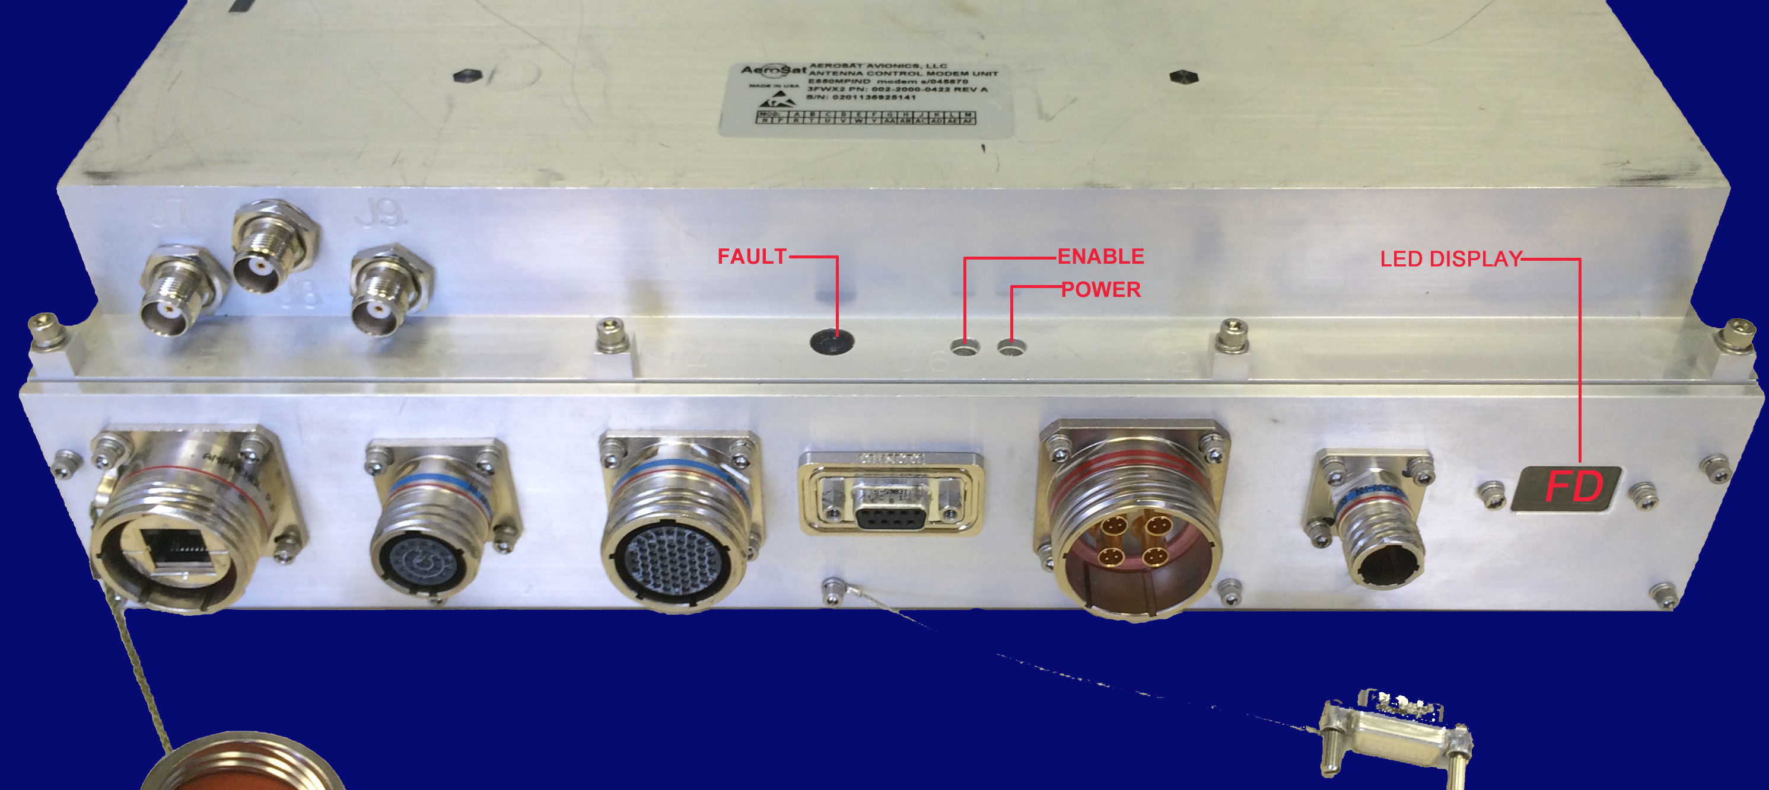

### Fault Ball

The **Fault Ball** does not require power to provide indication and is normally black in color. Any showing of white indicates a serious internal fault has been detected within the ACMU and is sufficient indication to remove and replace that LRU. This indicator is mechanically held in-state, remains white once triggered, and will not reset with a power cycle or reboot.

### Power Indicator

The **POWER** indicator will be green for a normally powered system. If not lit, power is not reaching the LRU or the internal power supply has failed. This indicator will transition to Red or Amber after a brief Green indication during initialization. After 30-60 seconds, this indicator should transition to green. If it does not transition to Green, replace the ACMU.

### Enable Indicator

The **ENABLE** indicator lights when the system is fully initialized. The indicator shows Amber when the satellite link is disabled either by command or a detected warning or fault condition. The indicator shows Green when the satellite link is completely operational. An obstructed location will inhibit transmissions on the ground resulting in an Amber indication. If this indicator remains unlit after the unit has been powered for 90 seconds or when the ENABLE indicator lights, replace the ACMU.

### LED BIT Code Display

The ACMU also has a two-digit LED BIT code display to provide fault codes caused by external dependencies or to flag a GAU fault. This display is updated whenever internal Built-in Test (BIT) is executed, with any detected error codes displayed in sequence roughly once per second and repeated continuously.

### [B] ACMU LED Indicators during Boot Sequence

The Power and Enable LEDs go through a color sequence upon power up, as shown in **Table 7.1**.

Figure 7.2 — ACMU LED Indicators during Boot Sequence

|  |  |  |
| --- | --- | --- |
| **Initialize** | **Out of Circuit** | **In circuit** |

**Table 7.1: [IR] ACMU Status Indicators**

|  |  |  |  |  |
| --- | --- | --- | --- | --- |
| ACMU | POWER | ENABLE | FAULT BALL | STATE OF SYSTEM |
| OFF STATE | OFF | OFF | BLK | No Power Applied |
| POWER | GRN | OFF | BLK | Just Powered; Capacitor Bank Charging |
| INITIALIZE | RED | OFF | BLK | Boot Sequence Begins (in seconds) |
| BOOT | GRN | OFF | BLK | System Boot Complete (30 seconds) |
| OUT OF CIRCUIT | GRN | AMBER | BLK | Unlocked: System Searching for Satellite |
| IN CIRCUIT | GRN | GRN | BLK | Closed: System Communicating via Satellite |
| FAULT | X | X | WHITE | ACMU fault detected – Replace ACMU |

In **Figure 7.3** — ACMU Status Indicators, the indicators show that power is applied, the system has completed initialization, no internal fault has been detected, and the system is presently not enabled.

Figure 7.3 — ACMU Status Indicators

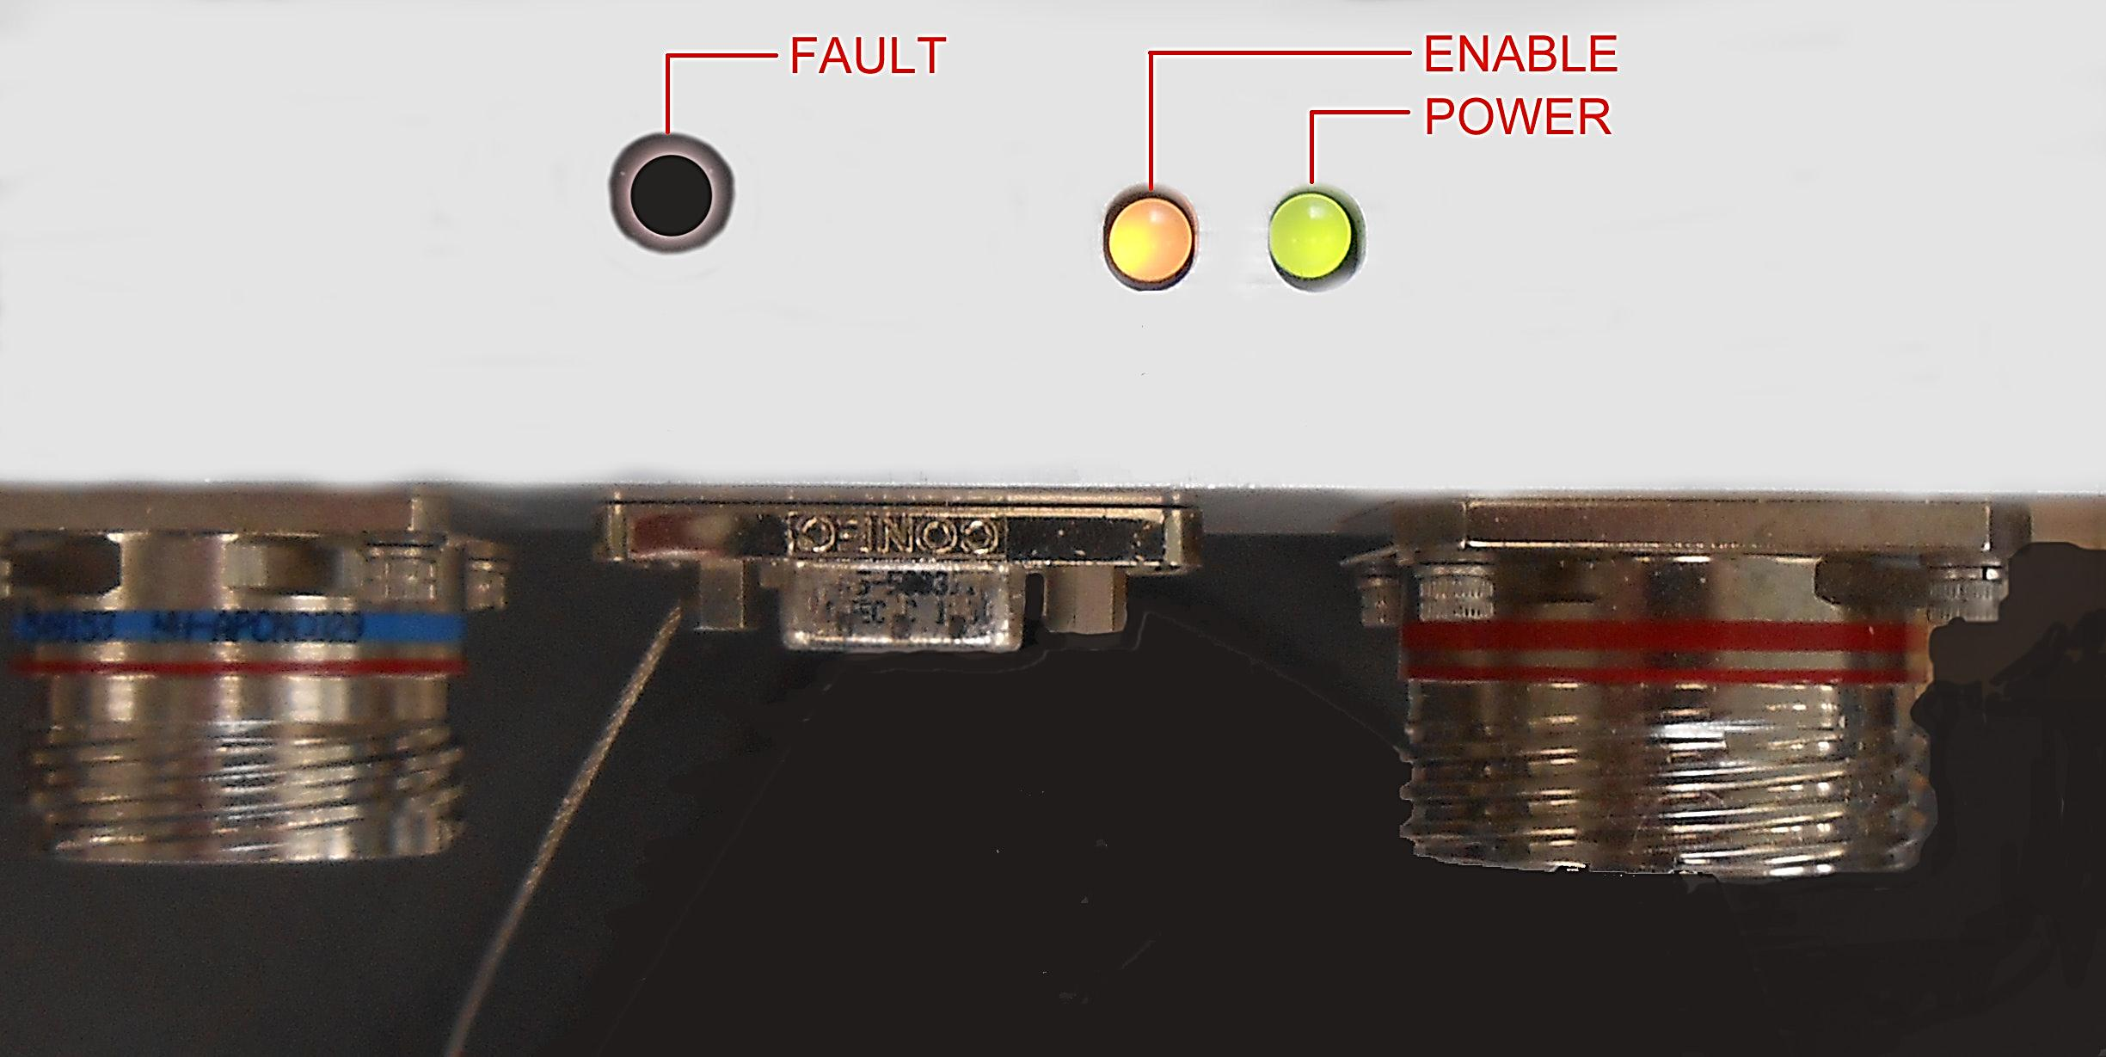

### [B] ACMU LED Display Warning Codes

The ACMU has a two digit LED BIT display located on the front of the box which will report codes in a two character alpha-numeric format. These codes are useful for identifying external faults and loose or missing cable connections. This display is updated whenever internal Built-in Test (BIT) is executed, with any detected error codes displayed in sequence roughly once per second and repeated continuously. If this indicator displays the code 88 (all LED segments lighted) then the ACMU has detected a fault in the GAU and the GAU must be replaced.

**note**

This display may be upside down or sideways if the ACMU is mounted other than with the attachment points up (J1/power and Display on the left; RF cables on the right).

During the boot-up sequence the ACMU will display various codes as internal tests are executed. When boot-up is complete any detected errors will be displayed in sequence for approximately 1 second with a pause between repetitions. As errors are cleared, these codes will be removed from the list of displayed codes. A normally operating system will have a blank display.

**If error codes are displayed together with the fault ball displaying a white indication, record the displayed codes and report this information as part of the equipment return process.**

**A display of 88 indicates a GAU fault has been detected and the GAU should be replaced.** Note that there may be instances where a GAU failure will not trigger display of the 88 code.

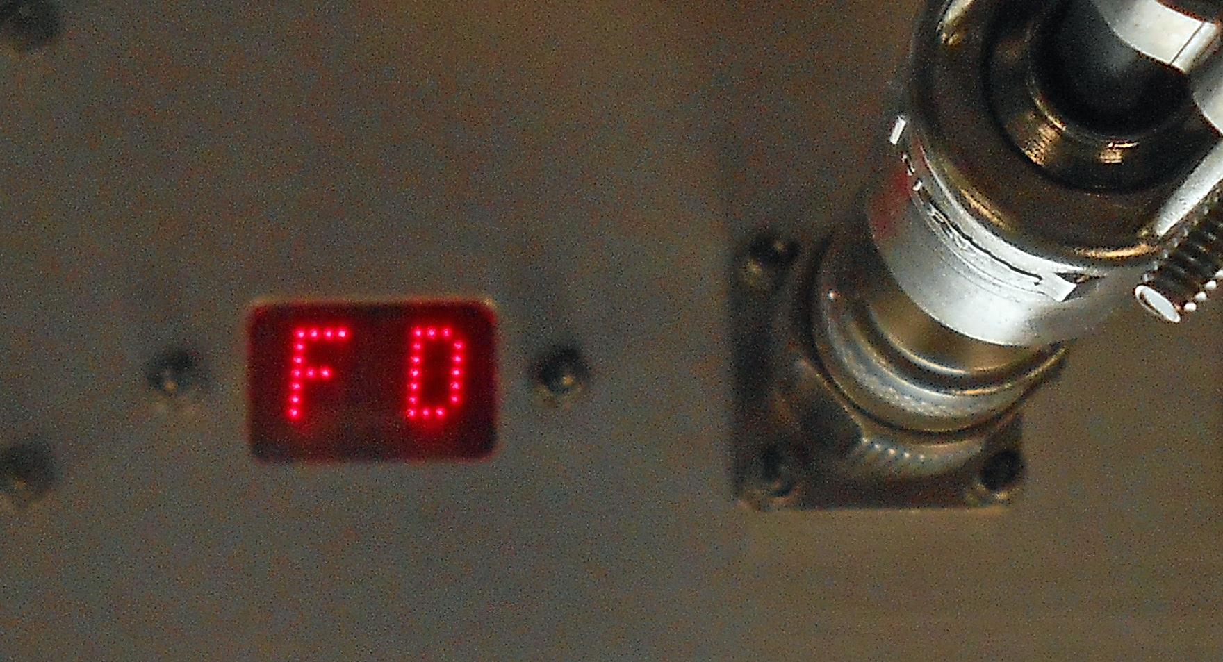

**Figure 7.4: [B] ACMU LED Display**

### [B] ACMU Fault Codes for ACMU Replacement

If a fault code listed in **Table 7.2** is presented on the ACMU LED display, the ACMU is likely faulted and should be replaced.

**Table 7.2: [B] ACMU Fault Codes Indicating ACMU Replacement**

| **FAULT CODE** | **SUBSYSTEM** |
| --- | --- |
| 00 - FAULT | FIRMWARE FAULT |
| 02 - FAULT | Micro Driver Fault |
| 03 - FAULT | PIU Fault |
| 04 - FAULT | IOU Fault |
| 05 - FAULT | MCU Fault |
| 06 - FAULT | PSU Fault |
| 0B - FAULT | Modem PWR Fault |
| 11 - FAULT | Message Bus Fault |
| 12 - FAULT | Az Motor Control Fault |
| 13 - FAULT | El Motor Control Fault |
| 14 - FAULT | Pol Motor Control Fault |
| 15 - FAULT | INS Driver Fault |
| 17 - FAULT | Management Interface Fault |
| 1D - FAULT | AC State Fault |
| 1E - FAULT | PIC Start Fault |
| 1F - FAULT | PIC Application Fault |
| 21 - FAULT | Point Application Fault |
| 25 - FAULT | Modem Start Fault |
| 26 - FAULT | System Start Fault |
| 28 - FAULT | Nav Start Fault |
| 29- FAULT | HPT Start Fault |
| FF - FAULT | App Start Fault |

### [B] ACMU Fault Codes for External Problems

Some ACMU LED display codes can help detect incorrect or missing cable connections. If one of the fault codes listed in **Table 7.3** is present on the LED display, check the corresponding cabling.

**Table 7.3: [B] ACMU Fault Codes Indicating External (Cable) Problems**

|  |  |
| --- | --- |
| **FAULT CODE** | **SUBSYSTEM** |
| 16 | No navigational data. The INS is not powered, not aligned or the cable connection incorrect) |
| 0F | A break exists in the ACMU J4 to GAU cabling |
| 16, 1C | The ACMU J3 is disconnected |
| 1C | The HPT J3 is disconnected |
| 1A | HPT J2 or ACMU J2 is disconnected |

## HPT

The HPT has status and fault indicators that can be observed on the cover: Power, Status and a Fault Ball, as shown in **Figure 7.5** — HPT Indicators.

Figure 7.5 — HPT Indicators



The Fault Ball does not require power to provide indication and is normally black in color. Any showing of white indicates a serious internal fault has been detected within the HPT and is sufficient indication to remove and replace that LRU. This indicator is mechanically held in-state, remains white once triggered, and will not reset with a power cycle or reboot.

The POWER indicator will be green for a normally powered system. If the POWER LED is not green, power is not reaching the LRU or the internal power supply has failed. If the indicator is unlit and power at J1 checks good, replace the HPT.

The ENABLE indicator lights when the system is fully initialized. The indicator shows Amber when the satellite link is disabled either by command or a detected warning or fault condition. The indicator shows Green when the satellite link is enabled. An obstructed location will inhibit transmissions on the ground resulting in an Amber indication. If this indicator remains unlit after the unit has been powered for 90 seconds or when the ENABLE indicator lights, replace the HPT.

## [B] Time-Available Fault Isolation

When more time is available for fault isolation, a laptop with a web browser can be used to perform system evaluation and fault isolation. Firefox and Google Chrome are approved for use, but Internet Explorer is not supported at this time. This fault analysis is primarily focused on verifying and identifying a fault with an LRU prior to investing the time required for a replacement. The web browser will be used to monitor the operation of the HR133/HR160 Antenna System via a web portal hosted by the ACMU.

## [1] Configuring and Connecting the Laptop to the ACMU

To configure and connect the laptop to the ACMU:

1. Manually configure the computer Ethernet/Network address via the control panel/preferences per the instructions in APPENDIX A.
2. Connect a laptop to the ACMU with a commercial RJ45 Ethernet cable to the covered J5 Maintenance port on the ACMU.
3. Open a standard web browser and browse to:

**192.168.64.10**

* 1. **[B]** **Monitoring System Operation via the Web Page**

The web page hosted at address 192.168.64.10 is shown below in **Figure 7.6**. This web site and the linked pages are used to monitor and control the HR133 Antenna System.

At the top right of the page are links to various reportable sections of the HR133/HR160 system. These links are explained in the following paragraphs in greater detail. To return to the Control Application page from any other page simply click on the AeroSat emblem located at the top left corner of all linked pages.

ARINC 429 navigation data from the aircraft INS, including data arrivals is shown in the LOCATION & ORIENTATION section of the web page

Signal Level, Pointing angles, Tracking Offsets, overall system status information, and Tracking Status are shown in the SYSTEM STATUS section at the bottom of the web page.

**Note**

The web page images shown in the following figures are representative. The web pages may be updated over time to include additional information or show a different organization.

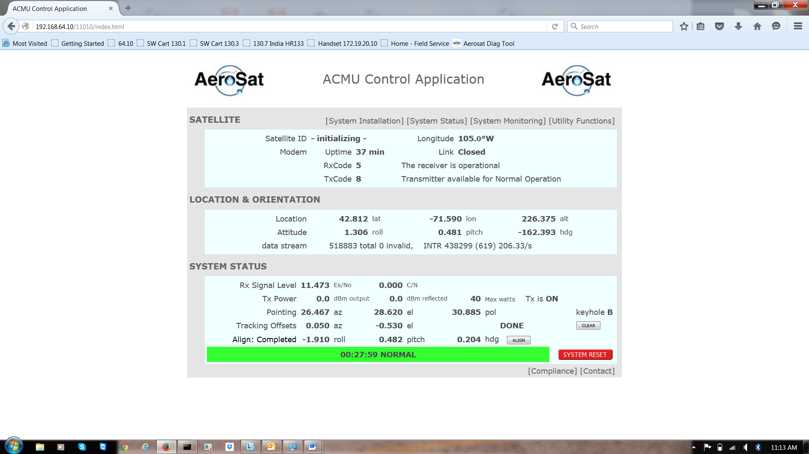

**Figure 7.6: [B] Typical HR133/HR160 Antenna System Web Site Home Page**

* 1. **[B]** **Examples of Network-Inhibited and Normal Web Pages**

The following web pages show a normal system receiving a signal from the selected satellite but inhibited from transmitting due to location on the ground. Note that the status indicates Normal in a Green Status Bar. Note also that the Link Status is Locked and not Closed.

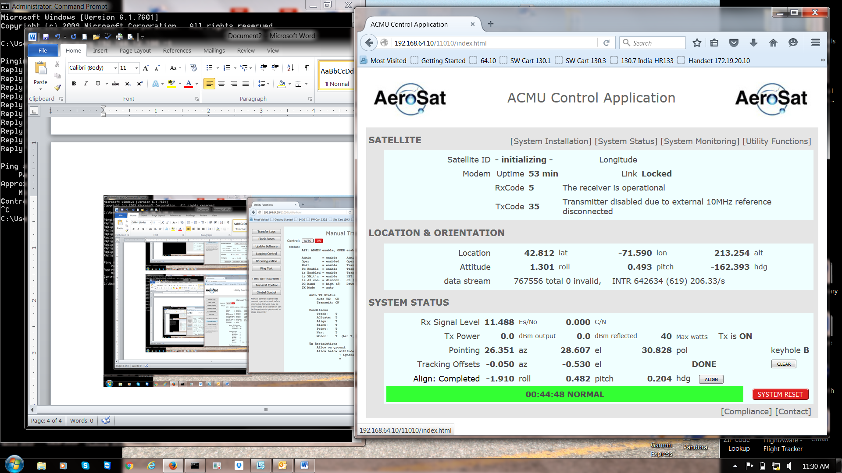

### [B] Normal System Status Web Page

Access the Normal System Status Web Page, shown in **Figure 7.7**, by clicking the **System Status** link at the top of the Control Application page (refer to **Error! Reference source not found.**).

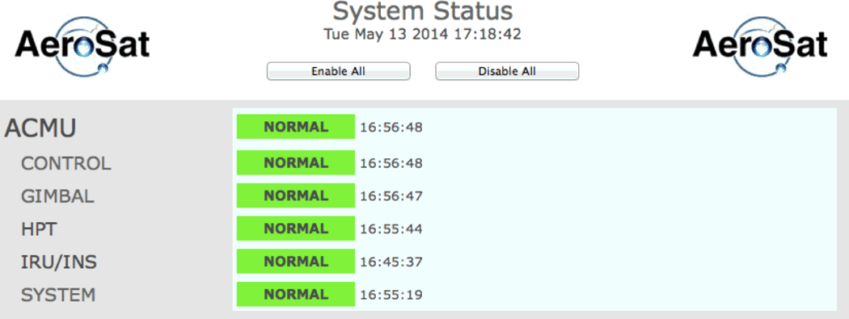

**Figure 7.7: [IR] Normal System Status Web Page**

### [1] Normal System Status with Expanded Details

Access Expanded Details for the Normal System Status Web Page, as shown in **Figure 7.8**, by clicking on each of the five control names listed to the left. Expanded Details can be minimized by clicking on the control name a second time.

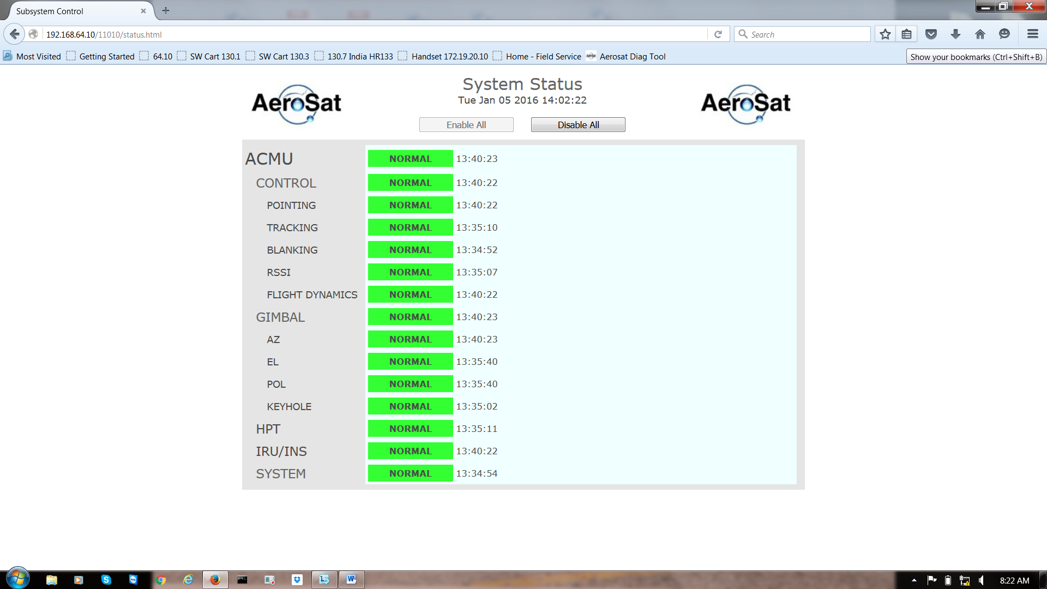

**Figure 7.8: [B] Normal System Status Web Page with Expanded Details**

* 1. **[B]** **GAU Fault Isolation and Verification**

The following web pages show a system with a failed GAU. Note that the Gimbal Status page indicates axis failures most likely attributable to the GAU. Note the WARNING Status and Yellow Status Bar. In the System Status page, the warning is broken down into a Fault by the Gimbal of the GAU. In the expanded System Status page, the Fault is identified as existing in the Elevation axis.

### [B] Faulted Main Web Page

The main web page with a fault condition displayed is shown in **Figure 7.9**.

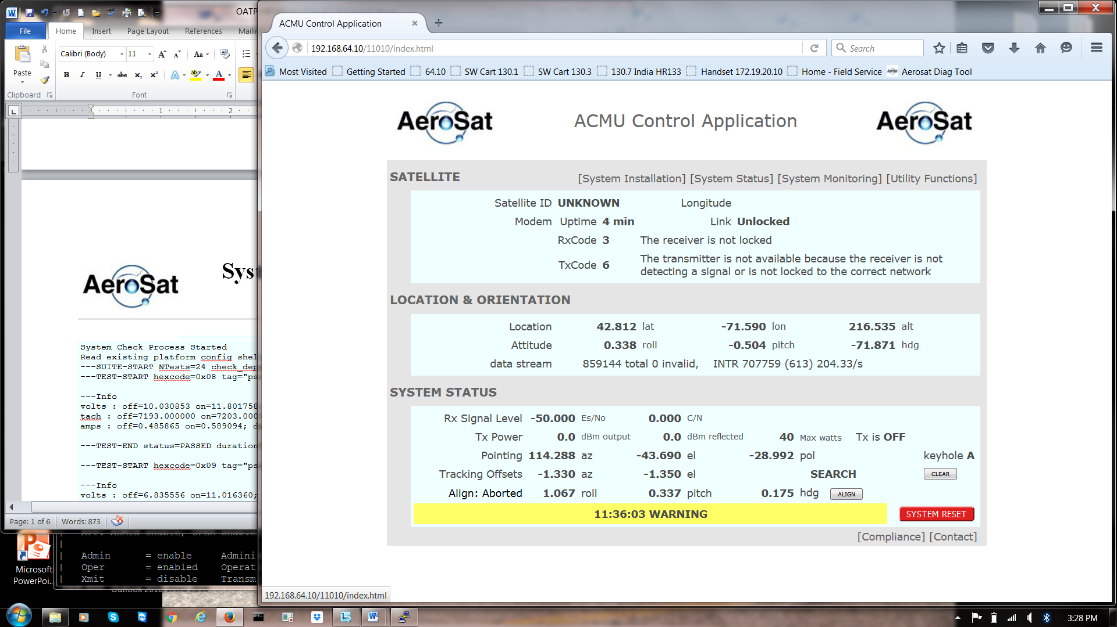

**Figure 7.9: [IR] Faulted Main Web Page**

### [B] Faulted System Status Web Page

Access the System Status Web Page by clicking the **System Status** link at the top of the Control Application page.

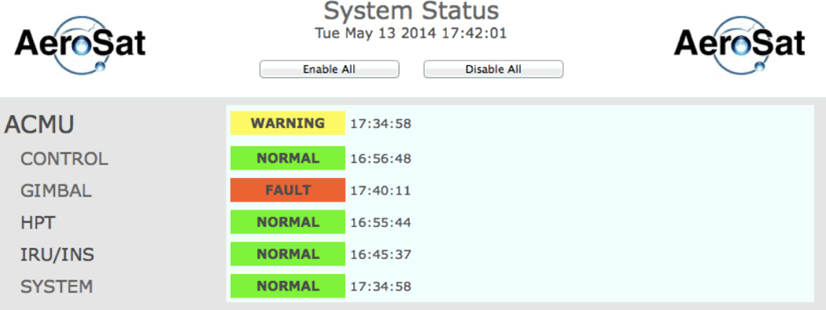

**Figure 7.10: [IR] Faulted System Status**

Access the Faulted System Status Web Page with Expanded Details, shown in **Figure 7.11**, by clicking on the **GIMBAL** control name (refer to **Figure 7.10**).

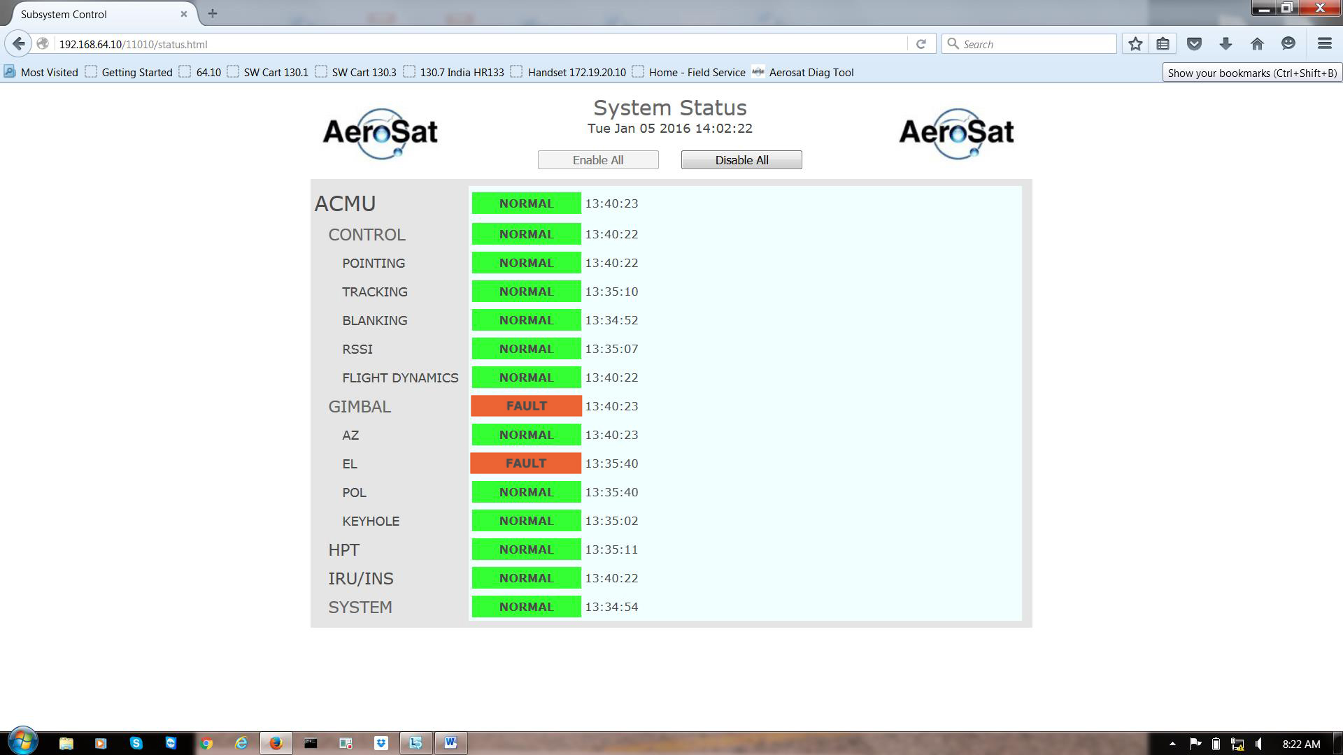

**Figure 7.11: [1] Faulted System Status with Expanded Details**

* 1. **[1]** **GAU Axis Investigation Fault Example**

Further examination of the failure can be done using the Gimbal Control page, accessed from the Utility Functions tab on the Control Application main page – see Figure 7-1 – and is depicted in the following pages.

Access the Gimbal Control Page, shown in **Figure 7.12**, through the Control Application main page, then click the Utility Functions link.

In the example shown in **Figure 7.12**, the axis shows a status of Fault

* The MO field has changed from 1 to 0
* The MF field has changed to 0x40.
* The HY field reporting 1 instead of 0 indicates that the gimbal has failed to calibrate.
* The Actual and Motor positions reported for this axis differ by >0.4 degrees.

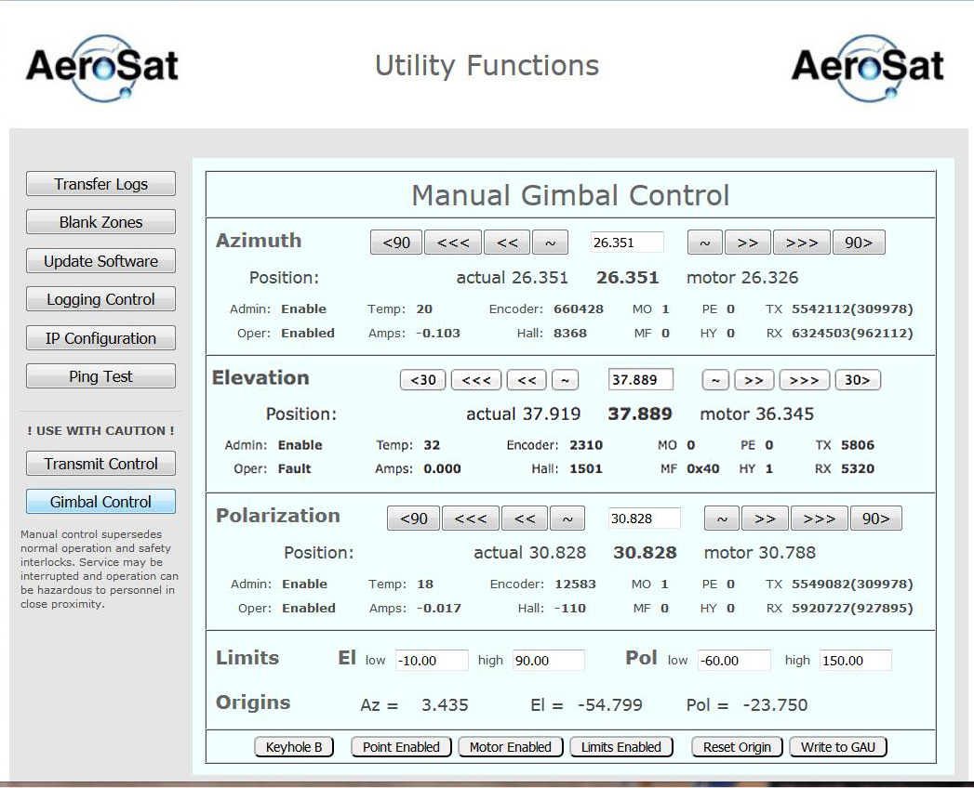

**Figure 7.12: [1] Faulted Gimbal Control Web Page**

For comparison, normal operational data is shown in **Figure 7.13**

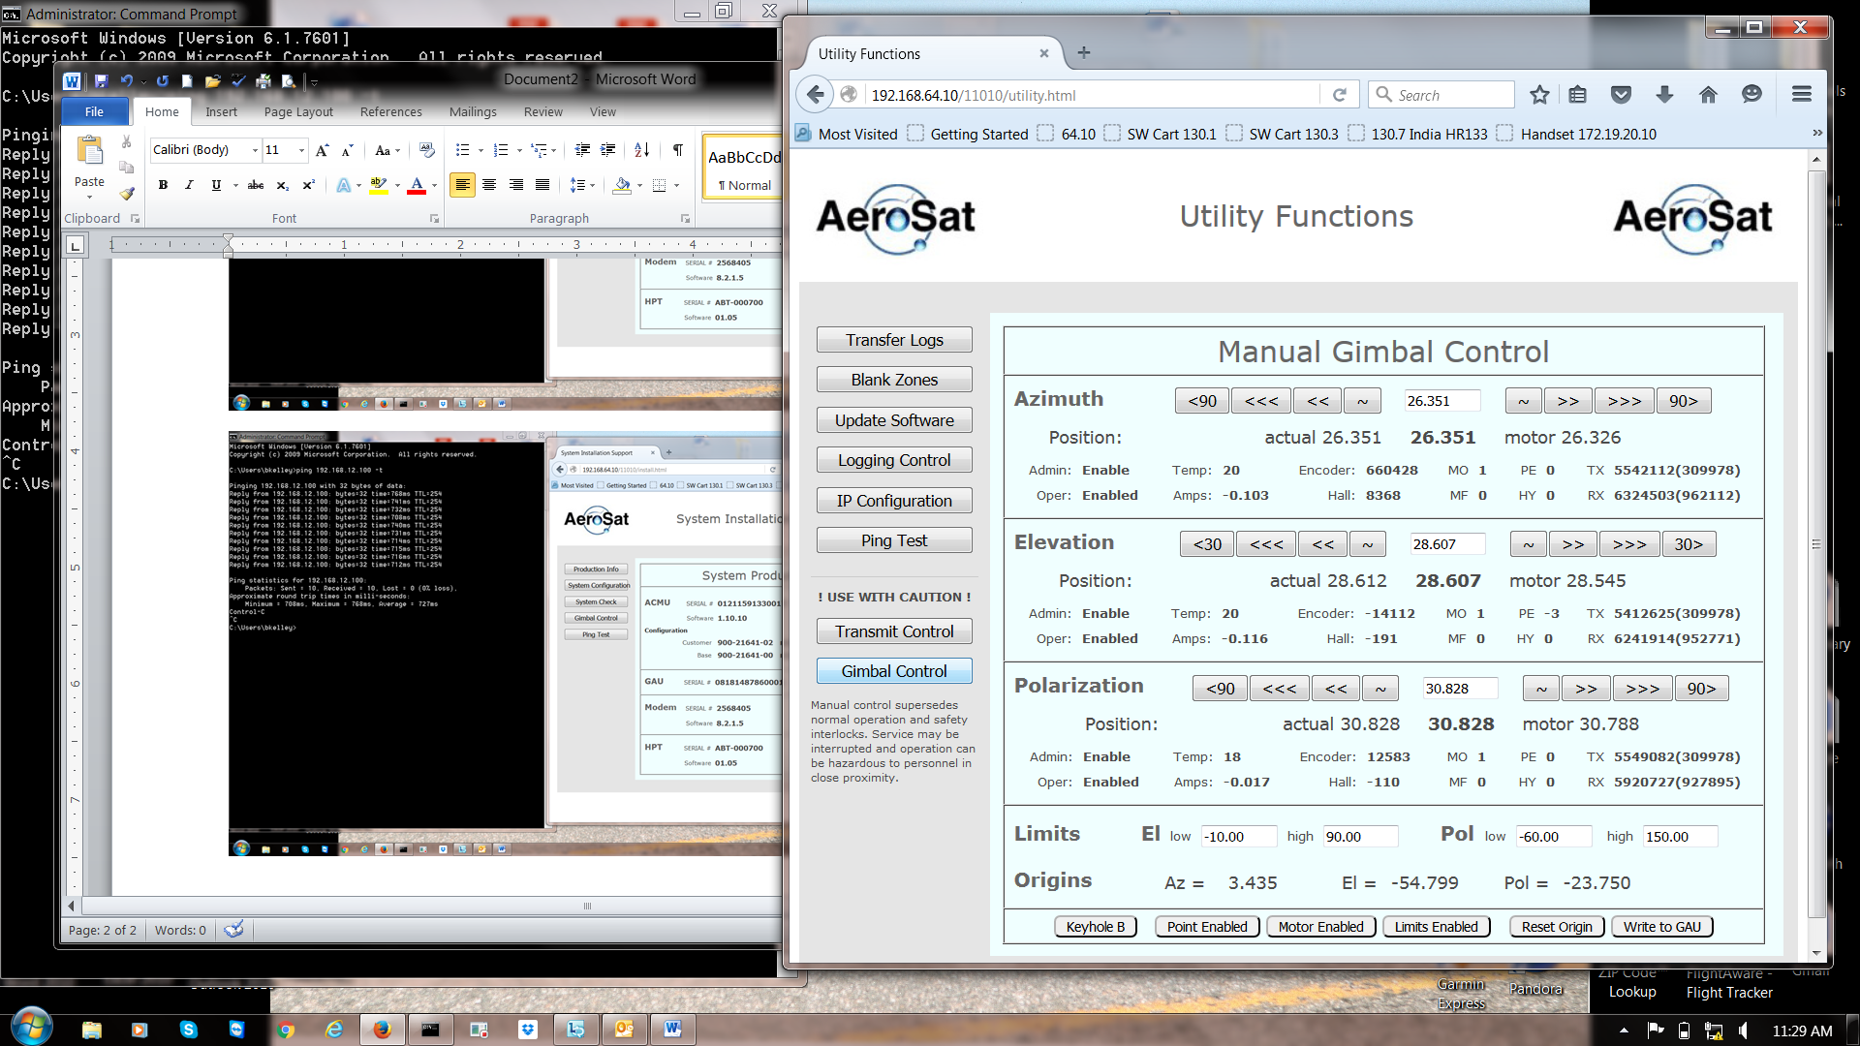

**Figure 7.13: [1] Normal Gimbal Control Web Page**

[1] GAU is suspected to be in failure

* Navigate to the System Installation Page



* Next navigate to the Gimbal Control Page

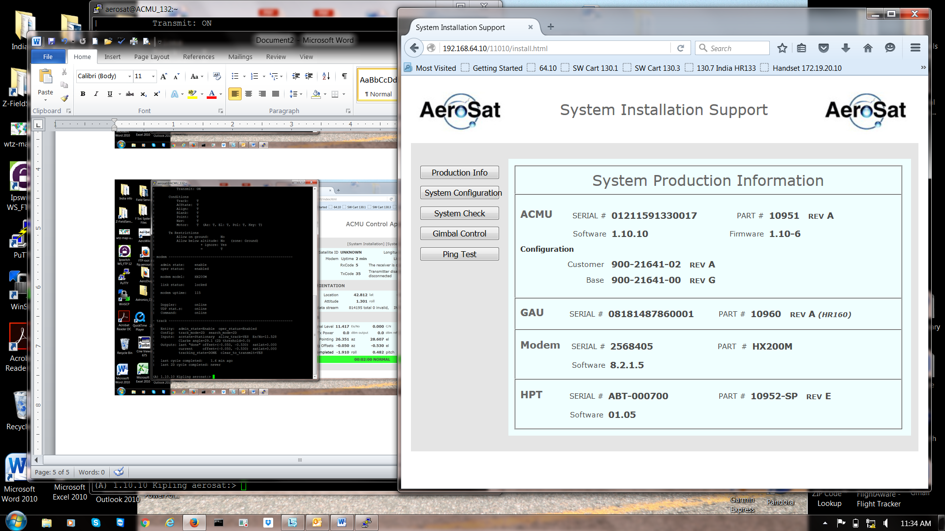

\*\*\***Note: The use of this Gimbal Control Page is the ONLY authorized gimbal control page for non-AeroSat personnel. Use of the Other Gimbal Control Page can result in permanent damage to the equipment and will require Factory level repairs.\*\*\***

* Once at the Gimbal Control page disable Point by selecting the button on the bottom left of the page named Point Enabled. Once selected the button will rename itself to Point Disabled. This will allow you to control the FMU as required in the following steps.
* Perform a functional checkout of the FMU’s range of motion by manually selecting each axis to move to the soft limits prescribed below.
  + Azimuth can rotate 360° and has no limits, it will read -179.99° through 179.99° with 0° being the forward fixed position.
  + Elevation can only rotate from -10° to 90°, if it exceeds or will not reach these limits by more than 0.200° contact AeroSat Personnel for assistance
  + Polarization can only rotate from -60° to 150°, if it exceeds or will not reach these limits by more than 0.200° contact AeroSat Personnel for assistance.
* Move the Azimuth Axis in increments of 30° in both positive and negative directions repeatedly and without delay 10 times in each direction. Note the difference in the Actual, Commanded, and Motor. Any difference greater than 0.200° is unacceptable and is cause for further guidance by AeroSat Personnel.

**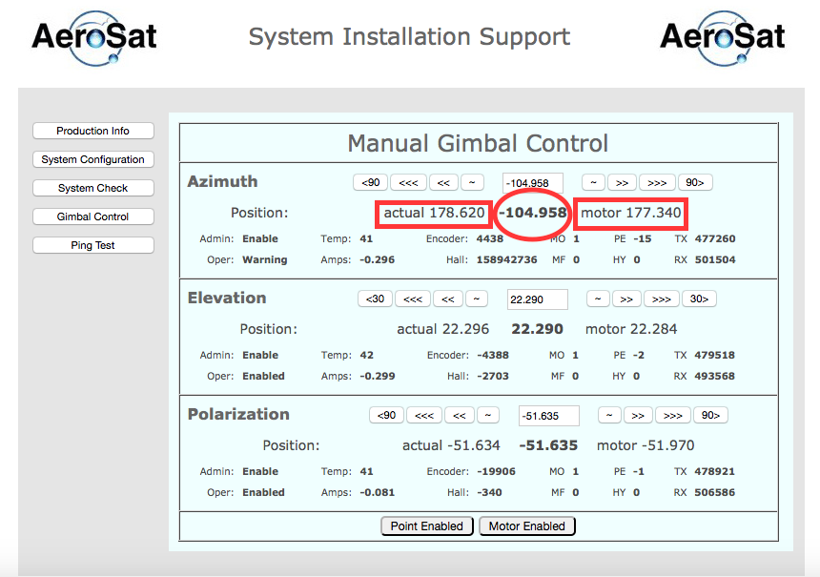**

**\*\*\*Note: The number annotated with the oval is the Commanded angle\*\*\***

* Prior to performing any other action re-enable Point by selecting the Point Disabled Button at the bottom of the page; it will change to say Point Enabled after selected.
* To ensure the Point application is enabled after the next reboot it is imperative that you navigate to the System Status Page as detailed in step 6. Once there you must select the Disable All button at the top of the page. (Shown Below)

**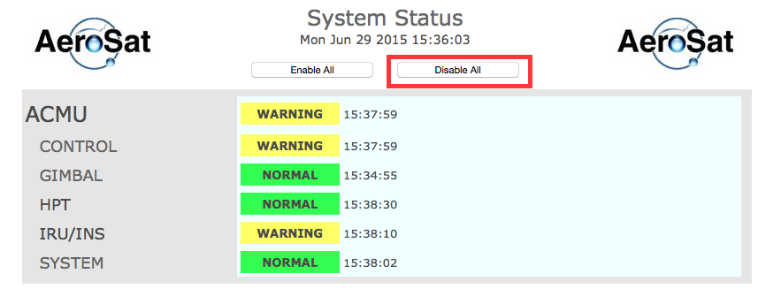**

* After selecting the Disable All button the status of all systems will change to grey and will say disabled, only then can you select “Enable All” to re-enable all the subsystems of the overall system.

**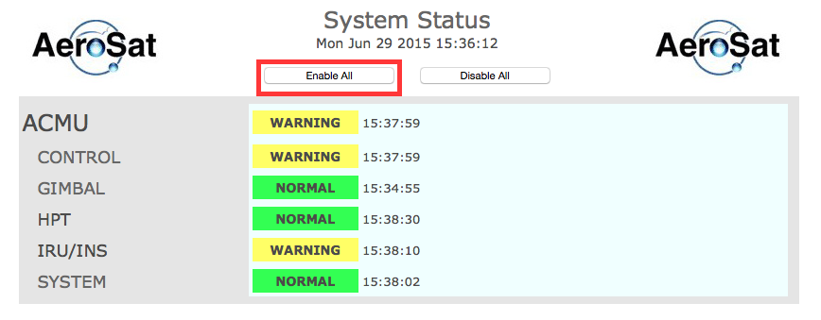**

* Once the Enable All button has been selected and all the systems have returned to the Normal (Green) status the system should be reset and then power cycled to ensure the system will power on correctly.
* Return to the system main page and click on the red System Reset button.

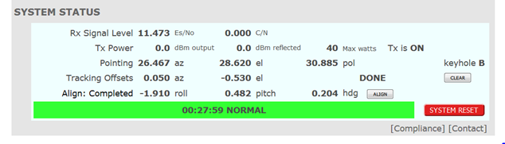

* Allow the reset process to complete, this sets the Enabled state as the current default. Then power cycle the system to lock the setting in and return to the Gimbal Control page to check that the state is still “Enabled” after the reboot is completed.
  1. **[B] Receiving the Satellite Signal but cannot close the link**
* Ensure that all ACMU, HPT and FMU cables are correctly connected.

**NOTE:** Disconnection of the J3 cable from either the ACMU or HPT will disable transmission. This is a fail-safe (lock-out) feature to ensure that personnel working atop the aircraft cannot be exposed to hazardous RF radiation.

* Verify that the Modem Configuration Parameters are correct.
  1. **[B]** **ACMU Fan Failure**
* Open HR6400 page on the Web interface
* Open the System Monitoring page

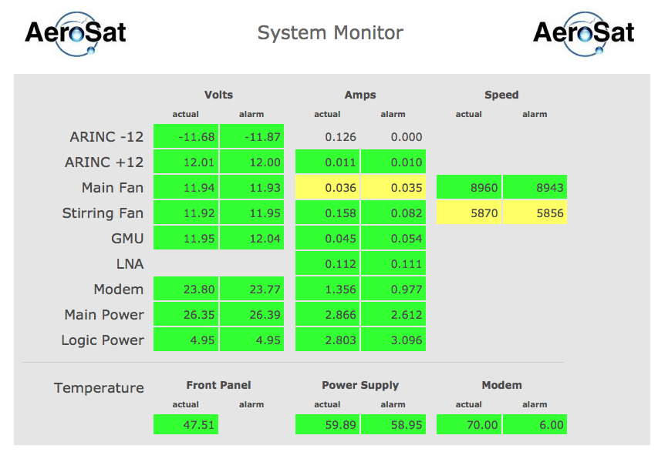

* Both fan voltages should be approximately 12 volts
* If the Main Fan or Stirring Fan amperages are backlighted in yellow, ACMU replacement is suggested at the soonest available opportunity, if Red, ACMU replacement is required as soon as practical
  1. **[B] Fails to Receive Accurate Location/Orientation Data**
* Ensure that the aircraft INS is powered and has completed alignment. Alignment can take up to 15 minutes during which the aircraft must not be moved.
* Ensure that all ACMU and ARINC-429 cables are correctly connected.
* The information in the “data stream” row will continuously increase without invalid packets if performing correctly
* If no data is populating in the “data stream” the likely faults are as follows
  + Cabling (ACMU connector J3 direct Rx from IRU)
  + Cabling (check GPS Coax cable condition and connectors fully screwed onto IRU and antenna)
  + Navigation Application Failure (Power Cycle system)
  + ACMU J3 port failure



# [A] ACMU System Check Codes

This appendix contains a list of common codes that you may see when a system check is run.

* If the code indicates the system could not start the component, the component is malfunctioning and may need replacement.
* If the code indicates mismatched versions or configurations, this may be the first boot after a software update, and a subsequent reboot **after system check is complete** may clear the error.

## [A] System “Not Installed” State

The “Not Installed” state is the state the system will be in when initially provisioned and before flight. When the system is in the “Not Installed” state, the sequence of tests and corresponding LED codes will be as follows:

Table A. — Numerical LED Hex Codes

| LED Hex Code | Test Name |
| --- | --- |
| 00 | Main Board BIOS |
| 02 | PIC Driver |
| 03 | PIU Module |
| 04 | IOU Module |
| 07 | IOU Config. EEPROM |
| 05 | MCU Module |
| 06 | PSU Module |
| 08 | PSU Fan1 Power |
| 09 | PSU Fan2 Power |
| 0A | PSU GMU Power |
| 0C | PSU ARINC Power |
| 0F | GAU Connected |
| 10 | GMU Module |
| 2A | GMU Config. EEPROM |
| 2B | Gimbal Config. |
| 0B | PSU Modem Power |
| 0D | PSU Heater Power |
| 0E | PSU LNA Power |
| 11 | Start Messagebus |
| 1E | PIC App Start |
| 21 | Point App |
| 12 | AZ Motor Controller |
| 13 | EL Motor Controller |
| 14 | POL Motor Controller |
| 15 | IRU/INS Driver |
| 16 | IRU/INS Data |
| 17 | Management Interface |
| 18 | Management IP Address |
| 1D | ACState App |
| 20 | Motor App |
| 1F | PIC App |
| 23 | Motor Calibration |
| 1A | High Power Transceiver |
| 1B | HPT Version |
| 1C | HPT Discrete |
| 29 | HPT App |
| 24 | Modem Connectivity |
| 30 | Modem Software Version |
| 27 | Modem Options File |
| 25 | Modem App |
| 26 | Sys App |
| 28 | Nav App |
| FD | GMU VPD Data |
| FE | IOU VPD Data |

## [A] System “Installed” State

When the system is in the “Installed” state (has flown), the sequence of tests/(LED codes) will be as follows

Table A. — Numerical LED “Installed” State Hex Codes

| LED Hex Code | Test Name |
| --- | --- |
| 02 | PIC Driver |
| 03 | PIU Module |
| 06 | PSU Module |
| 04 | IOU Module |
| 07 | IOU Config EEPROM |
| 05 | MCU Module |
| 0B | PSU Modem Power |
| 0E | PSU LNA Power |
| 11 | Start Messagebus |
| 17 | Management Interface |
| 18 | Management IP Address |
| 26 | Sys App |

## [A] Web-based System Check Numeric LED Codes

The following table lists the sequence of the LED Hex Codes that will display on the ACMU during a system check that is performed through the SATCOM System web-based application.

Table A. — Web-based System Check Numeric LED Hex Codes

| LED Hex Code | Test Name |
| --- | --- |
| 08 | PSU Fan1 Power |
| 09 | PSU Fan2 Power |
| 0A | PSU GMU Power |
| 0C | PSU ARINC Power |
| 0B | PSU Modem Power |
| 0D | PSU Heater Power |
| 0E | PSU LNA Power |
| 21 | Point App |
| 28 | Nav App |
| 16 | IRU/INS Data |
| 1D | ACState App |
| 2B | Gimbal Config. |
| 20 | Motor App |
| 23 | Motor Calibration |
| 1A | High Power Transceiver |
| 1B | HPT Version |
| 1C | HPT Discrete |
| 29 | HPT App |
| 24 | Modem Connectivity |
| 30 | Modem Software Version |
| 27 | Modem Options File |
| 25 | Modem App |
| 28 | Nav App |
| FF | Start Remaining Apps |

# [A] Computer Configuration

## [A] Objective

The objective of this procedure is to configure the test computer to communicate with the ACMU.

## [A] Configure the Maintenance Computer

Table B — Configure Test Computer Procedure

| Step | Action |
| --- | --- |
| 1. | Navigate to the **Windows Control Panel**. |
| 2. | In the **Network Connections** menu, right click the **LAN** connection then click **Properties**.  Figure B.— Network Connections Menu |
| 3. | In the **Properties** menu, select **IPv4** then click **Properties**.  Figure B. — Networking Tab |
| 4. | In the **IPv4 Properties Menu**, do the following:   * Click Use the following IP address. * Enter 192.168.64.100 in the **IP address** field. * Enter 255.255.255.0 in the **Subnet mask** field.   Figure B. — General Tab |
| 5. | Press **OK** to exit the **Control Panel**. |

**[A] APPENDIX C WIRING DIAGRAMS**

C1 Dornier 228 HR133 Installation Wiring Diagram

* Configuration #1: with AeroSat INS
* Configuration #2: with IAI Tammam INS

**C2** Ilyushin IL-38 HR160 Installation Wiring Diagram

* C1 - HR133

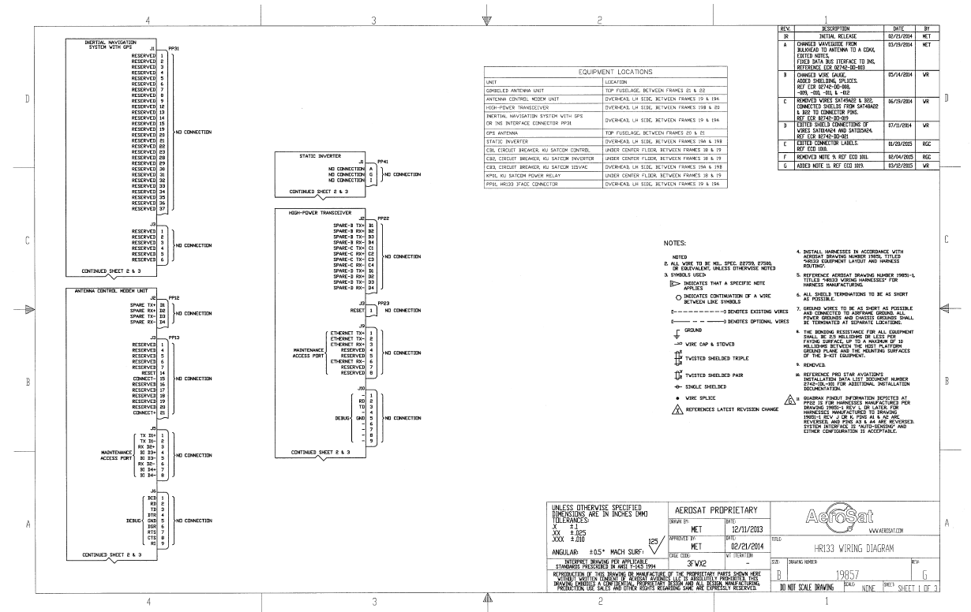

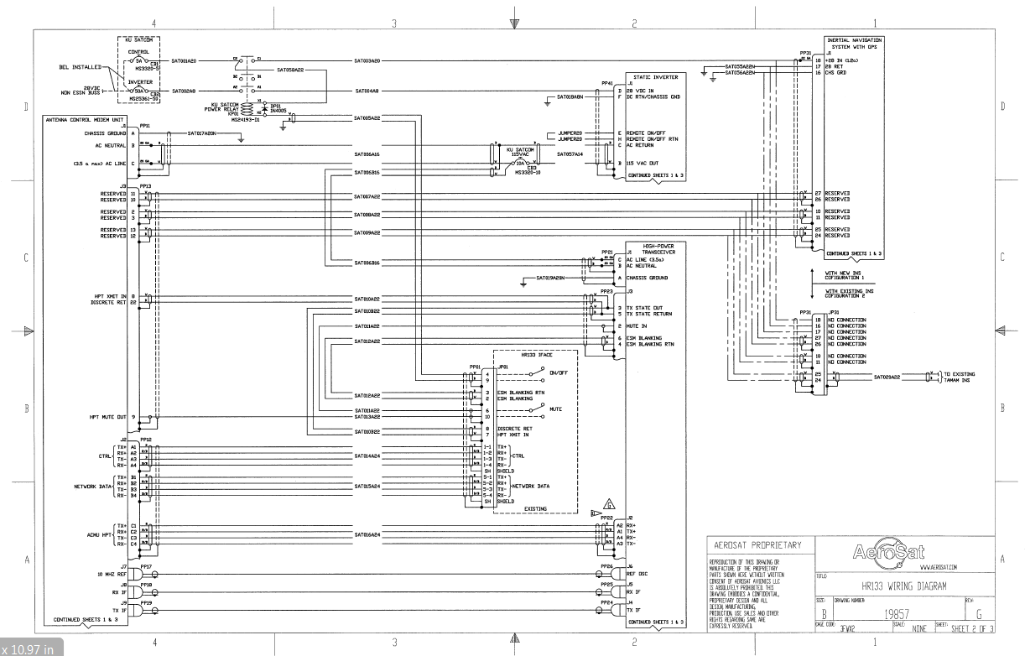

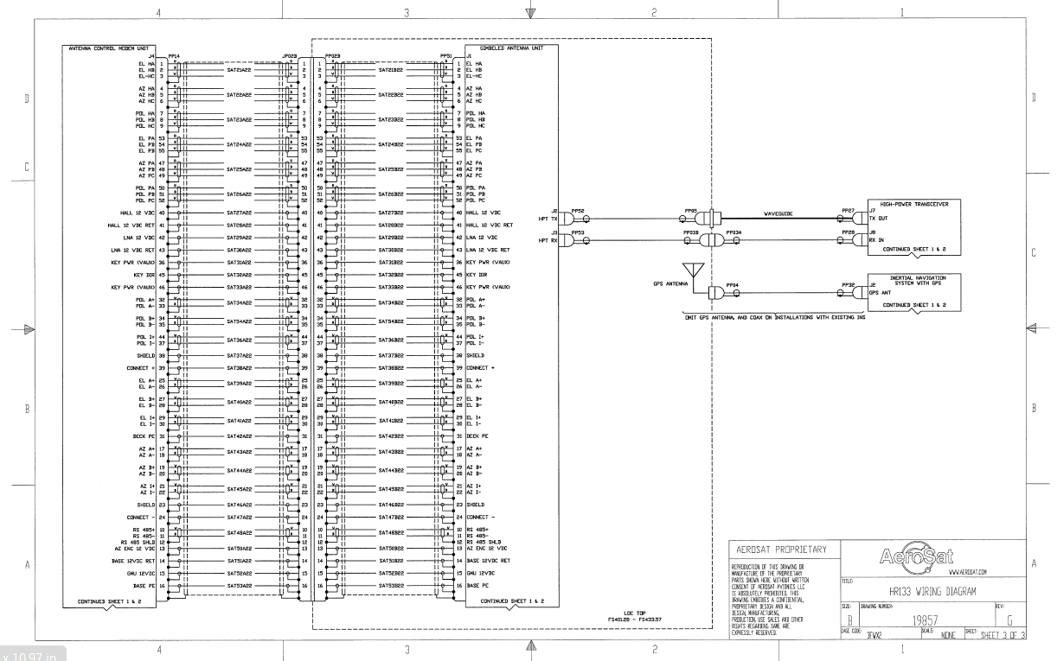

* C2 - HR160

